From Homeless to Heaven Sent
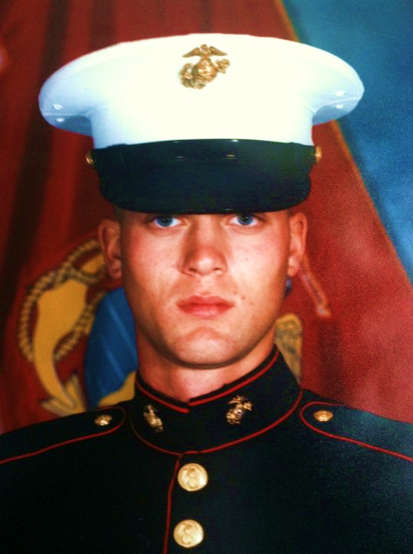
William Charles Rima (pronounced “Rhyme-ah”) was born in Auburn, Washington in 1974 to parents who realized by the time he was 18 months old that they weren’t going to be able to care for him, so they gave him up to his aunt and uncle, who raised him on an Indian reservation in Eastern Washington, which is where he graduated from high school, then married his high school sweetheart and made the choice to enter the U.S. Marines. He was stationed in Camp Pendleton, California and saw time in Okinawa and Korea over his 8-year hitch before he made a “family decision” in 2000 to get out of the military and on with his life. By this time he had a young daughter, his first marriage had ended, and a second began.
He worked at Teradyne – an automated tester company - where he first moved testers, and eventually programmed them, but was laid off. Then he worked for a spin-off of Teradyne for three years from 2004 t0 2007 in Irvine, California. He started showing signs of schizophrenia, though, and separated from his wife, then moved back to Eastern Washington with his aunt and uncle again. But, with no job, he eventually wore out his welcome. So, with a little food and a propane torch in a pack on the back of a bicycle, he rode in September and October back to Kent over Stevens Pass – a journey that took him ten days to accomplish. His goal was to see his mom, but he couldn’t stay with her as she lives in an assisted care facility.
Being homeless, hunger was a paramount concern, so when he was hungry he went to a church in Federal Way. Before he learned about community supper meals, William found change on the ground and used it to buy Top Ramen that he cooked with that handy-dandy propane torch he had presence of mind to bring along with him on his bicycle from Eastern Washington.
When William was first diagnosed with schizophrenia, he didn’t want to tell anyone, and he definitely didn’t want to take his meds, but eventually he realized he needed help and started taking them. He’d tried to file a claim with the Marines for a disability, but they rejected that. He came to the “Blue House” in Kent – an Alcoholics Anonymous group, in other words – to help with one of the complications of his marriage separation. In 2008 he tried to die, taking a lot of sleeping pills and vomiting them up. He slept a long time after that, but at least he didn’t die. He spent a total of three years as a homeless person, sleeping in the Federal Way woods on private properties. He remembers that many homeless people left messes, which bothered him. It became such a problem, in fact, that the owners of the properties eventually sold and the police cracked down on the homeless camps, so after that he then slept under the eave at Calvary Lutheran Church in Federal Way atop a piece of cardboard he’d fished out of a dumpster.
When the seasons changed, people from outreach programs would give him a coat, or shoes, or boots. He said he wore out so many pairs of shoes just walking. One winter he got to stay in a shelter – the South Sound Dream Center – between Steel Lake Church and Calvary Lutheran Church. Summers they could camp. He spent a lot of time in the library. Early mornings he walked and sat in the Commons Mall in Federal Way.
He developed what he felt was a “ministry” of making cigarettes for people, rolled from used butts. William tells it that God gave him the idea. He’d buy rolling paper with change that he found, then used a drinking straw fitted with a make-shift funnel that he devised, dumped in the tobacco from the butts, tamped it down and rolled the paper around it to make the cigarettes that he used in his ministry to give away to other homeless people.
He subsisted on one to two meals a day from church suppers for homeless people. There was a weekly circuit of where to go. Monday night was supper at Kent Lutheran. Tuesday night they congregated at First Evangelical Presbyterian. Saint Stephen the Martyr Catholic church would send a bus to pick people up at Kent Lutheran (where they’d eaten the night before) until someone who was drunk broke out a window. Wednesday’s dinner was served at Trinity Church, Thursday and Friday nights were Calvary Lutheran in Federal Way’s offering, and on Saturdays the Seventh Day Adventist Church folks in Renton would send a bus to pick up the homeless at Kent Station. Since 2009, on Sundays William has shown up to Kent Lutheran for their after service coffee hours. He eventually started attending their services, too. He says that he loves the traditional service style of worship there.
William remembers that being able to find work as a homeless person was a problem, “Because you needed to be showered and clean-shaven.” Labor Ready never worked out, but Catholic Community Services referred him to a shelter, then he made his way to Seattle to Fair Start to become a cook. With a little employment, he was able to find a place to stay, and then got a physical at the V.A., and started treatment for schizophrenia in 2010, but because of his schizophrenia diagnosis, Fair Start didn’t work out. His next stop was to stay at the Salvation Army’s William Booth Center in the International District of Seattle, but he was still having schizophrenia problems and when he had an altercation at the William Boot Center and felt wronged, he threw his stuff in the trash and went homeless again. As he puts it, then “A real life angel appeared” and referred him to Compass Center. A Veteran’s counselor there coordinated him even more with the V.A. He spent three months at Compass Center before he moved into the Mark Cooper House – a Veterans only facility. After that, he took his meds every day and started working as a vendor for Real Change – a Seattle progressive street newspaper.
As William puts it, “Then a miracle happened.” A social worker helped take his case to a lawyer to get SSDI. He got a “Severely Homeless Voucher” for low-income housing from the V.A., moved to Auburn, and became a member of Kent Lutheran Church, where he worshipped every Sunday, always greeting everyone he met with a handshake and a warm smile. He was given a reduced fare bus pass because of his diagnosed disability, and he got a food handler’s permit, then started volunteering at ALL the community suppers that previously kept him alive to give back because he really loved the fellowship and wanted to help others to get help, too. “Many of those homeless people had been in that predicament for 20 years or more. Some choose to be that way,” he says.
William used to argue about the Bible with Pastor Jane Prestbye at Kent Lutheran, but now he agrees with her. He felt the urge for formal education of God and the Bible, so he spoke with her of how he wanted to use his knowledge and his homelessness experience to take the Christian sacraments to the homeless. “They need communion, too,” William stresses. Pastor Jane was a former professor at Trinity Lutheran College, so she contacted them with his information. He later applied and was accepted as a student there, and he’s learned a lot. He used to think respect wasn’t in the Bible – just love – now, though, he knows both are there. He’s pretty excited about how he sees God show up in his everyday life. “It’s amazing!” he says with infectious enthusiasm.
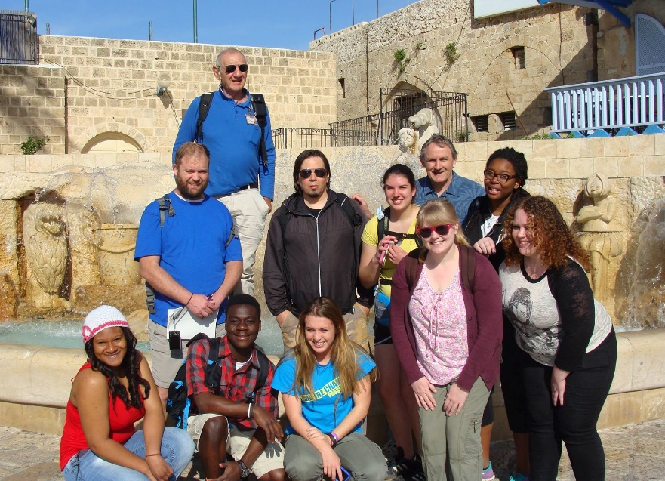
A few years back the congregation at Kent Lutheran experienced the bittersweet joy and sorrow of praying William on to his next adventure – his college education at Trinity Lutheran in Everett. He’d been accepted to their program and received $8,000 per year in scholarship. Then he experienced another miracle when he moved to a house “with an understanding manager,” he says, in Shoreline – the farthest north city in King County, so he could still use his bus pass. Another miracle: his bus route was going to be cut, but the voters nixed that notion. His college was in Everett, so he needed that transportation to get there, and God made it happen. From 2001 through 2007 he attended college part-time in California, studying general requirements toward an electrical engineering degree. Those credits were transferrable, so he finished up his degree in the last two and a half years at Trinity Lutheran College. During that time he was even granted a scholarship to go to the Holy Land. “It was amazing to walk in the same places Jesus walked,” William recalls. He just graduated with a Bachelor’s degree in Biblical Studies in the middle of June - Summa Cum Laude with a GPA of 3.94, no less - and was invited to be this year’s commencement speaker. It appears William Rima has something of importance to say… so much so that his wife came from California to hear it – and to go to dinner with him at the Space Needle. His daughter from his first marriage is 22 now, is married, and also is back in his life, though she lives in Alabama, so there’s a logistical problem to seeing her just yet.
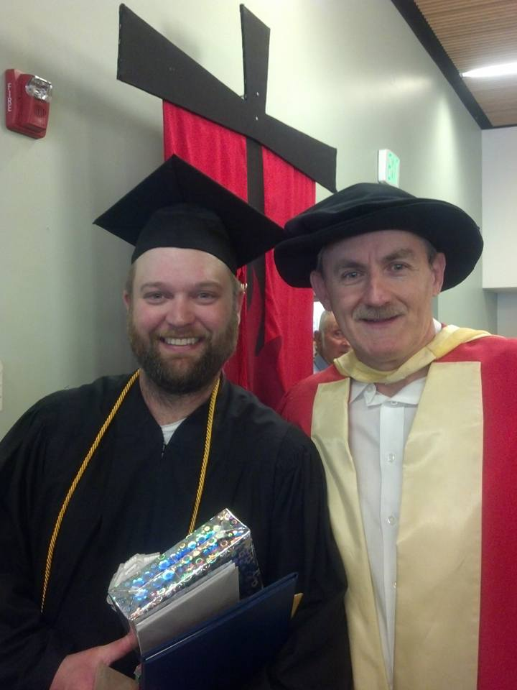
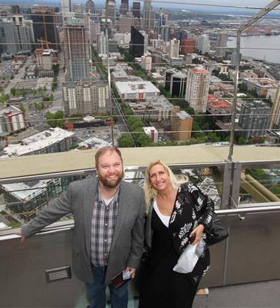
Now that he has an opportunity to think about life beyond just finding daily sustenance, William can concentrate more on his developing passions: studying the Old and New Testaments, and looking for new ways God presents himself in the Scriptures. God shows up every day in William’s life. “It’s amazing!” he exclaims.
The Sunday after he graduated, William came back to Kent Lutheran (a two-hour bus ride each way from Shoreline) with the dilemma of which university to go to next – Luther Seminary in St. Paul, Minnesota, or Pacific Lutheran Theological Seminary in Berkeley, California? Ah, but a Sunday later he returned to Kent Lutheran to tell us that an anonymous donor from the Evangelical Lutheran Church of America Synod had offered to pay his way for his first year ($18,000 worth) at PLTS, so that seems the logical place to go. ‘Another sign from God? He worked on his application at the Kent Library after church to submit, just in case they needed more direction than that one from God on the matter. William now wants to become a pastor. He’s already been offered candidacy by the ELCA upon completion of school “…and a big checklist of other stuff,” William tells us. Specifically, the fire in his belly is to work with homeless people. “Life is uncertain – vita incerta est,” he rattles off in Latin.
William remembers he once had a psychology professor who instructed him to start writing a daily list of five things he was thankful about for a month. “It’ll change you,” the professor said. William took the assignment to heart – and, indeed, it certainly has changed his heart. What he wants people to remember about him is, “That he really did God’s work with the homeless –that he really gave of himself to the needy.” My guess is that he’ll achieve those dreams… and so much more.
William has proven his educational ability, but he still could use financial assistance with clothing and the things of everyday life. If you feel moved to share in his educational advancement, monetary contributions can be made to Kent Lutheran Church and earmarked “William Rima” at 336 – 2nd Avenue S, Kent, WA 98032, or by calling the church office at (253)852-2078.

