International Committee for Future Accelerators (ICFA)
Standing Committee on Inter-Regional Connectivity (SCIC)
Chairperson: Professor Harvey Newman, Caltech

ICFA SCIC Network Monitoring Report

Prepared by the ICFA SCIC Monitoring Working Group
On behalf of the Working Group:
Les Cottrell cottrell@slac.stanford.edu



2011 - 2012 Report of the ICFA-SCIC Monitoring Working Group
Edited by R. Les Cottrell, Shawn McKee, Amber Zeb
On behalf of the ICFA-SCIC Monitoring WG
Created November 10, 2011, Finished January 28, 2012
ICFA-SCIC Home Page | Monitoring WG Home Page
This report is available from:
http://www.slac.stanford.edu/xorg/icfa/icfa-net-paper-jan12/report-jan12.doc

Table of Contents
Executive Overview 5
Introduction 8
Additions to report 8
Methodology 8
PingER Results 9
Deployment 9
Historical Growth of PingER Coverage Since 1998 11
Metric Meanings 11
Yearly loss trends: 12
Yearly minimum RTT 13
Yearly Throughput Trends 15
View from Europe 17
Variability of performance between and within regions 18
Yearly Mean Opinion Score (MOS) trends 20
Comparisons with Economic and Development Indicators 21
Human Development Index (HDI) 22
The Digital Opportunity Index (DOI) 23
Happy Planet Index (HPI) 24
PingER Case Studies 25
Japanese Magnitude 9.0 Earthquake 05:46 UTC March 11, 2011 25
The “Arab Spring” 26
Pakistan Education and Research Network 30
High Performance Network Monitoring 33
New and Ongoing Monitoring and Diagnostic Efforts in HEP 33
perfSONAR in USATLAS 37
LHCOPN Monitoring 41
LHCONE 43
Related HEP Network Research 44
Comparison with HEP Needs 45
Recommendations 45
Future Support 46
Acknowledgements 46
Appendices 48
Appendix A: ICFA/SCIC Network Monitoring Working Group 48
Goals of the Working Group 48
Appendix B: Presentations etc. in 2011. 48
Appendix C: New tools added in 2011 49
Tools and Infrastructure 49
Appendix D: Growth in Number of Sites Monitored this Millennium 51

Executive Overview
Internet performance is improving each year with throughputs typically improving by 20% per year and losses by up to 25% per year. Developed countries have converted from using Geostationary Satellite (GEOS) connections to terrestrial links improved performance in particular for Round Trip Time (RTT). GEOS links are still important to countries with poor telecommunications infrastructure, landlocked developing countries, remote islands, and for outlying areas. In some cases they are also used as backup or redundant links.
In general, throughput measured from within a region is much higher than when measured from outside. Links between the more developed regions including N. America, E. Asia (in particular Japan, South Korea and Taiwan) and Europe are much better than elsewhere (3 - 10 times more throughput achievable). Regions such as Russia, S.E. Asia, S.E. Europe and Latin America are 5-9 years behind. However, Africa is ~19 years behind Europe. Currently, Africa’s throughput is 14 times worse than Europe and extrapolating the data tells that it will further degrade to 17 times in 10 years. Extrapolating the statistics last year indicated that Africa would be 30 times worse than Europe in 10 years. This significant improvement (from 30 times worse to 17 times worse) is due to the trend line steeper slope seen this year compared to last year. We account this improvement in performance from year to year to be due to the move from satellite to terrestrial links, in particular for East Africa.
Africa and South Asia are two regions where the Internet has seen phenomenal growth, especially in terms of usage. However, it appears that network capacity is not keeping up with demand in these regions. In fact many sites in Africa and India appear to have throughputs less than that of a well-connected (cable, DSL, etc.) home in Europe, North America, Japan or Australia. Further the end-to-end networking is often very fragile both due to last mile effects and poor infrastructure (e.g. power) at the end sites, and also due to lack of adequate network backup routes. Africa is a big target of opportunity with over a billion people and a 1329.4% (compared to 3.9% for the world) growth in number of Internet users from 2000-2009. However, there are many challenges including lack of power, import duties, lack of skills, disease, corruption, and protectionist policies. In almost all measurements, Africa stands out as having the poorest performance and even worse is that it has been falling behind faster than other regions. Further Africa is a vast region and there are great differences in performance between different countries and regions within Africa.
Despite Africa’s dreadful performance exemplified by almost all network measurements, recent observations of performance to many Sub-Saharan sites give reasons for hope. This is driven by the recent installation of multiple new terrestrial (submarine) fibre optic cables, along both the East and West coasts of Sub-Saharan Africa, initially to provide connectivity for the 2010 World Soccer Cup in South Africa. By 2013 it is expected that there will about be 13 submarine cable systems serving Sub-Saharan Africa with a capacity exceeding 20 terabits and an investment approaching $4Billion US. Prior to the lighting of the first East African cable, in July of 2009, East African hosts were connected to other regions via GEOS links, with a minimum of 450ms RTTs to anywhere. Such long RTTs make interactivity dreadful, Voice over IP impractical, and badly impact throughput that is inversely proportional to RTT. As hosts had their connections moved to the fibre optic cable, RTTs improved by factors of 2 to 3 and with the extra capacity, losses and jitter were also reduced. Furthermore, these improvements were not just to coastal countries such as Kenya, but were quickly extended to landlocked countries such as Uganda and Rwanda. For the longer term, the provision of multiple cables from different companies is resulting in competition and significant price reductions. For example in Nairobi 15 months after the arrival of the submarine cables, there is competition between 4 providers, and prices have dropped to $300/Mbps. This is to be compared with the African average in 2008 of over $4000/Mbps. But it will take a while yet before the competition spreads to the smaller towns in the region.
There is a moderate to strong positive correlation between the Internet performance metrics and various economic and development indices available from the UN and International Telecommunications Union (ITU). Besides being useful in their own right these correlations are an excellent way to illustrate anomalies and for pointing out measurement/analysis problems. The large variations between sites within a given country illustrate the need for careful checking of the results and the need for multiple sites/country to identify anomalies. Also given the difficulty of developing the human and technical indicators (at best they are updated once a year and usually much less frequently); having non-subjective indicators such as PingER that are constantly and automatically updated is a very valuable complement.
For modern HEP collaborations and Grids there is an increasing need for high-performance monitoring to set expectations, provide planning and trouble-shooting information, and to provide steering for applications. As link performance continues to improve, the losses between developed regions are decreasing to levels that are not measureable by PingER. Though the measurements for RTT, jitter, and unreachability are still correct, as the measured losses go to zero this also makes the throughput derivation unreliable. Alternative solutions to measuring the throughput are available, however they can be harder to install and absorb more network bandwidth. Examples of other measurement projects using the more intense methods are the MonALISA project that uses the pathload packet pair technique as well as file transfers, and perfSONAR that uses the iperf TCP transport mechanism. There is also a project in place at SLAC and LBNL under the perfSONAR umbrella to analyze and present data from production gridFTP transfers that are heavily used in the HEP community. These projects are becoming increasingly important for links between well developed sites.
Given the problems with throughput derivations for low loss regions, we have introduced the Mean Opinion Score (MOS). This gives the quality of a phone conversation and is a function of the RTT, loss and jitter, thus combining several measures. This year we have also introduced a new metric “alpha” which for wide area networks mainly gives a measure of the directness of paths between sites.
To quantify and help bridge the Digital Divide, enable world-wide collaborations, and reach-out to scientists world-wide, it is imperative to continue the PingER monitoring coverage to all countries with HEP programs and significant scientific enterprises.

Introduction
This report may be regarded as a follow up on to the previous ICFA Standing Committee on Inter-regional Connectivity (SCIC) Monitoring working group’s Network reports dating back to 1997.
The current report updates the January 2011 report, but is complete in its own right in that it includes the tutorial information and other relevant sections from the previous report. The main changes in this year’s reports are given in the next section.

Additions to report
- Deployment of new PingER Monitoring nodes mainly in Pakistan. We now have ~ 94 active monitoring hosts in 23 countries. This is an increase of ~24 hosts since last year.
- Case studies of the impact on Internet connectivity of the Japanese earthquake and tsunami, and the uprisings in Tunisia, Egypt and Libya.
- Case study on the Pakistan Educational and Research network.
- We added the Happy Planet Index to our correlations with PingER data.
- Updating of the major figures and tables.
- New monitoring, analysis and reporting tools.

Methodology
There are two complementary types of Internet monitoring reported on in this report.
- In the first we use PingER which uses the ubiquitous "ping" utility available standard on most modern hosts. Details of the PingER methodology can be found in the Tutorial on Internet Monitoring & PingER at SLAC. PingER provides low intrusiveness (~ 100bits/s per host pair monitored) RTT, loss, jitter, and reachability (if a host does not respond to a set of 10 pings it is presumed to be non-reachable). The low intrusiveness enables the method to be very effective for measuring regions and hosts with poor connectivity. Since the ping server is pre-installed on all remote hosts of interest, minimal support is needed for the remote host (no software to install, no account needed etc.)
- The second method (perfSONAR etc.) is for measuring high network and application throughput between hosts with excellent connections. Examples of such hosts are to be found at HEP accelerator sites and the Large Hadron Collider (LHC) tier 1 and 2 sites, major Grid sites, and major academic and research sites in N. America, Japan and Europe. The method can be quite intrusive (for each remote host being monitored from a monitoring host, it can utilize hundreds of Mbits/s or more for ten seconds to a minute, each hour). To minimize intrusion, the US-ATLAS scheduling utilizes 20 second tests every 4 hours rather than every hour. It also requires more support from the remote host. In particular either various services must be installed and run by the local administrator or an account is required, software (servers) must be installed, disk space, compute cycles etc. are consumed, and there are security issues. The method provides expectations of throughput achievable at the network and application levels, as well as information on how to achieve it, and trouble-shooting information.

PingER Results

Deployment
The PingER data and results extend back to the start of 1995 with online data available from the start of 1998. They thus provide a valuable history of Internet performance. PingER now has ~94 active monitoring nodes in ~23 countries that monitor over 917 remote nodes at over 783 sites in over 165 countries (see PingER Deployment). These countries contain over 99% of the world's population (see Table 2: Quality ranges used for loss) and over 99.5% of the online users of the Internet. Most of the hosts monitored are at educational or research sites. We try and get at least 2 hosts per country to help identify and avoid anomalies at a single host. The requirements for the remote host are documented. Figure 1 below shows the locations of the monitoring and remote (monitored sites).
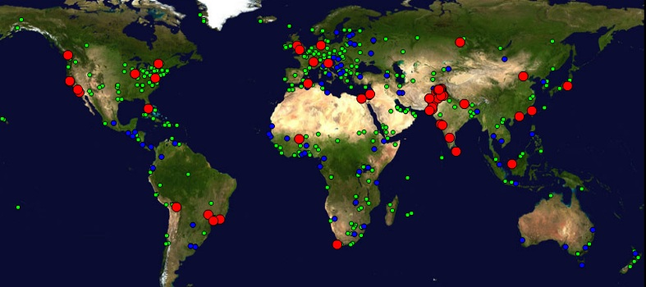
Figure 1 : Locations of PingER monitoring and remote sites as of Nov 2011. Red sites are monitoring sites, blue sites are beacons that are monitored by most monitoring sites, and green sites are remote sites that are monitored by one or more monitoring sites
There are several thousand monitoring/monitored-remote-host pairs, so it is important to provide aggregation of data by hosts from a variety of "affinity groups". PingER provides aggregation by affinity groups such as HEP experiment collaborator sites, region, country, Top Level Domain (TLD), or by world region etc. The world regions, as defined for PingER, and countries monitored are shown below in Figure 2. The regions are chosen starting from the U.N. definitions. We modify the region definitions to take into account which countries have HEP interests and to try and ensure the countries in a region have similar performance.
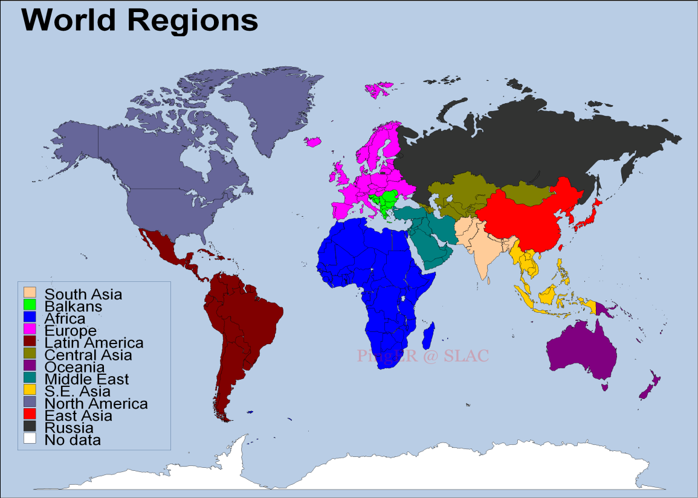
Figure 2 Major regions of the world for PingER aggregation by regions, countries in white are not monitored
More details on the regions are provided in Table 2 that highlights the number of countries monitored in each of these regions, and the distribution of population in these regions.

Table 1: PingER Monitored Countries and populations by region Dec 2011
Regions | # of Countries | Population of the Region | % of World Population
Africa | 46 | 1002115954 | 15%
Balkans | 10 | 66163226.59 | 1%
Central Asia | 9 | 77527376.65 | 1%
East Asia | 4 | 1554611116 | 23%
Europe | 30 | 524685841.2 | 8%
Latin America | 22 | 584048471.7 | 8%
Middle East | 15 | 294738640.7 | 4%
North America | 3 | 347319920.2 | 5%
Oceania | 4 | 34667630.29 | 1%
Russia | 1 | 140439510.4 | 2%
S.E. Asia | 8 | 588925127.8 | 9%
South Asia | 8 | 1615968386 | 23%
Total | 160 | 6831211201 | 99%

Historical Growth of PingER Coverage Since 1998
Figure 3 shows the growth in the number of active sites monitored by PingER from SLAC for each region since 1998. As can be seen, initially the main regions monitored were North America, Europe, East Asia, and Russia. These were the regions with the main HEP interest. More recently the increased number of hosts monitored in developing regions such as Africa, Latin America, Middle East and South Asia is very apparent.

Figure 3 : Number of sites monitored from SLAC by region at the end of each year 1998 – 2011

Metric Meanings
To assist in interpreting the losses in terms of their impact on well-known applications, we categorize the losses into quality ranges. These are shown below in Table 3.
Table 2: Quality ranges used for loss
 | Excellent | Good | Acceptable | Poor | Very Poor | Bad
Loss | <0.1% | >=0.1% &  < 1% | > =1%  & < 2.5% | >= 2.5%  & < 5% | >= 5%  & < 12% | >= 12%

The major effects of packet loss and RTT can be found in the Tutorial on Internet Monitoring & PingER at SLAC, briefly:
- At losses of 4-6% or more video-conferencing becomes irritating and non-native language speakers are unable to communicate effectively. The occurrence of long delays of 4 seconds or more (such as timeouts in recovering from packet loss) at a frequency of 4-5% or more is also irritating for interactive activities such as telnet and X windows. Conventional wisdom among TCP researchers holds that a loss rate of 5% has a significant adverse effect on TCP performance, because it will greatly limit the size of the congestion window and hence the transfer rate, while 3% is often substantially less serious, Vern Paxson. A random loss of 2.5% will result in Voice over Internet Protocols (VoIP) becoming slightly annoying every 30 seconds or so. A more realistic burst loss pattern will result in VoIP distortion going from not annoying to slightly annoying when the loss goes from 0 to 1%. Since TCP throughput for the standard (Reno based) TCP stack according to Mathis et. al. goes as 1460*8bits/(RTT*sqrt(loss)) it is also important to keep losses low for achieving high throughput.
- For RTTs, studies in the late 1970s and early 1980s showed that one needs < 400ms for high productivity interactive use. VoIP requires an RTT of < 250ms or it is hard for the listener to know when to speak.

Yearly loss trends:
Figure 4 shows the packet losses seen from SLAC to world regions for 1998 through 2011. Since losses are mainly dependent on the network edges, they tend to be independent of distance.
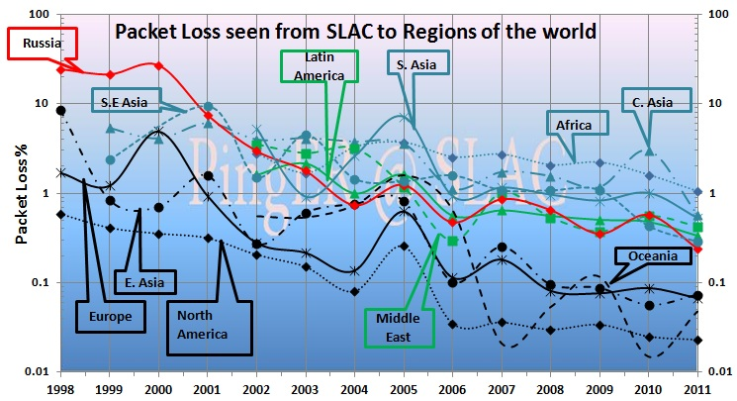
Figure 4: Packet Loss measured for various regions from SLAC in Nov 2011

It is seen that losses are lowest (best) for North America, East Asia, Europe and Oceania. They are highest (worst) for Central Asia and Africa. The improvement from year to year is roughly exponential with a factor of ~ 30 improvement in 10 years.

Yearly minimum RTT
In general for wide area paths the minimum RTT depends mainly on the length of the path between the two hosts. If the path uses a GEOS link then the round trip path for the radio signal is ~450-500ms. As can be seen for minimum RTT from SLAC to countries of the world in the figure below, there is a clear minimum RTTs threshold between 400 and 500ms between terrestrial paths and paths with GEOS links. It is also clear that most of the remaining countries monitored that still use GEOS links are in Africa.
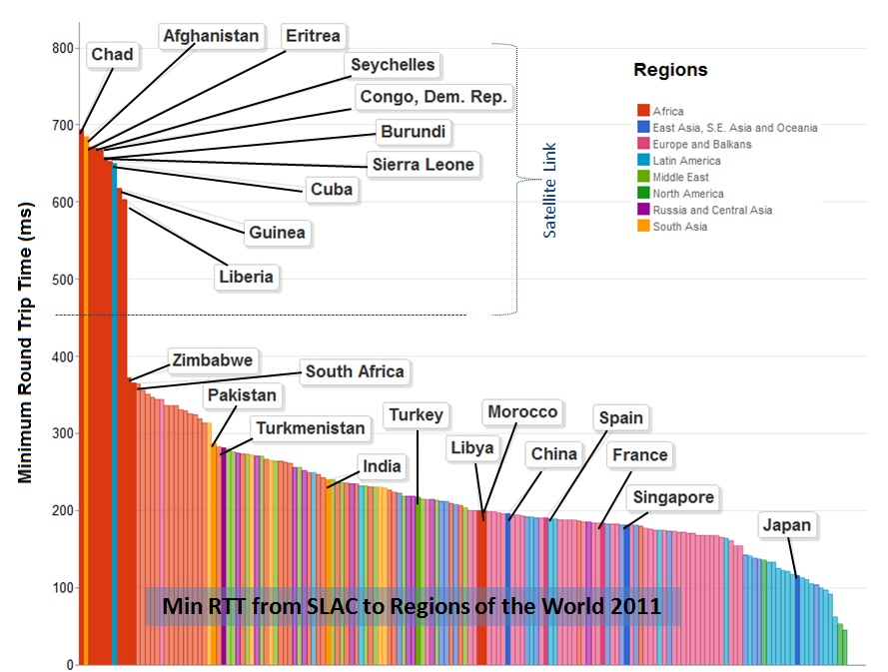
Figure 5: Minimum RTTs measured from SLAC to world countries, Nov 2011. Diferent regions have different colors.

If one looks at maps of the minimum RTTs from SLAC to the world in 2008 and 2011 in Figure 6, one can see the countries that have moved away (moved from red to another color) from using GEOS links. This is particularly apparent for East Africa where the installation of fibre cables from Europe and from the Middle East to East African countries driven by the 2010 soccer world cup in South Africa dramatically reduced round trip delays. One can also see Greenland now uses terrestrial links and in Central Asia only Afghanistan still uses GEOS links.

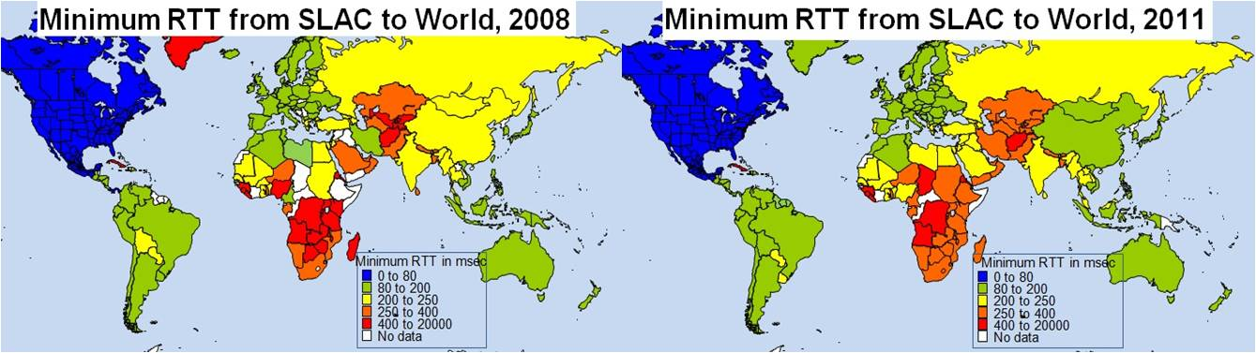
Figure 6: Maps of minimum RTTs from SLAC to the world in 2008 and 2011.

Looking at the minimum RTT as a function of time for many countries since 1998 seen in Figure 7, one can clearly see, by the precipitous drop in minimum RTT, when monitored hosts in various countries moved from GEOS satellite connections to terrestrial connections.
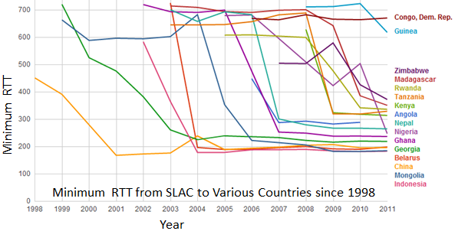
Figure 7: Time series of minimum RTT measured from SLAC to various countries since 1998

It can be seen that China shifted to a terrestrial link in 2001, Georgia in 2003, Indonesia and Belarus in 2004, Mongolia in 2006. Although Ghana received terrestrial connectivity in 2001, the nodes we were monitoring did not shift to a terrestrial connection until 2007. Rwanda, Kenya, Zimbabwe and Madagascar are some of the countries that started using terrestrial connections in 2010 due to the Soccer world cup in Africa. For the 46 countries we monitor in Africa, the following still have min-RTTs of over 500msec: the Democratic Republic of the Congo (DRC also known as Congo Kinshasa), Eritrea, Guinea, Liberia, Seychelles, Sierra Leone, and Chad. In addition we have been unable to find hosts to monitor in the Congo Republic (also known as Congo Brazzaville), South Sudan and the Central African Republic. Of these:
- Sierra Leone supported by a loan from the World Bank plans a submarine fibre optic connection early in 2012
- The Republic of Congo is building fibre infrastructure around the capital Brazzaville, and will connect to Pointe Noire on the coast where the submarine fibre optic cable lands
- Similarly the DRC is building fibre infrastructure connecting about 14 universities in Kinshasa. It will be connected to the submarine cable landing on the coast at Muanda, and also across the Congo river to Brazzaville.
- It is expected that Gambia, Guinea Bissau, Guinea, Liberia, Mautitania, Sao Tome and Principe and Equatorial Guinea will get their first submarine connections via the ACE project in 2012. The cable will also connect via terrestrial fibre networks in the landlocked countries of Mali and Niger.

Yearly Throughput Trends
To combine the effects of loss and RTT we use the Mathis formula to calculate the TCP throughput. We have also reduced the effect of the 1/RTT in the Mathis formula for derived throughput by normalizing the throughputs using:
norm_throughput = throughput * min_RTT(remote region) / min_rtt(monitoring_region),
where: throughput ~ 1460*8 bits/(RTT*sqrt(loss))
The results are shown in Figure 8 showing data averaged into yearly intervals.
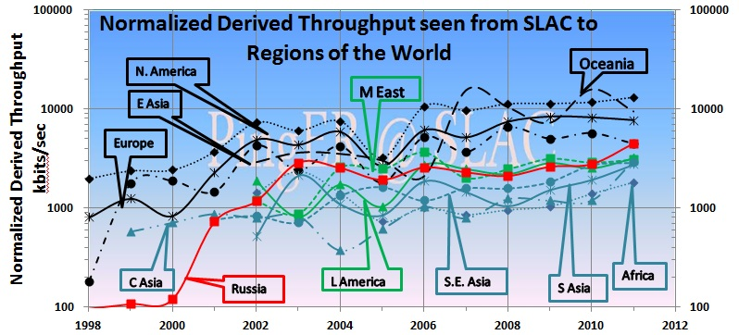
Figure 8: Yearly averaged normalized derived TCP throughputs from the SLAC to various regions of the world.
The improved performance for Russia in 2001 is an artifact of measuring a single host (the Institute of High Energy Physics in Moscow) with high losses in 1999-2000 and adding a second host (Institute of High Energy Physics in Novosibirsk) with low losses in 2001. Parts of Latin America moved from satellite to fibre in 2000, and E. Asia in 1999. Also note the impact of moving the ESnet routing from E. Asia (in particular Japanese academic and research networks) to the US via New York in 2001 to a more direct route via the West Coast of the US. Also note that there is almost a 10 times difference in throughput between Africa and N. America, Europe and Oceania. Finally note that Africa has been caught up and passed by S. Asia, Latin America, and Russia. Africa is now the worst off region and has the slowest rate of improvement.
To make the overall changes stand out more clearly, Figure 8 shows just exponential trendline fits to monthly averages of the derived throughput on a log-linear scale (exponentials show up as straight lines). We have excluded N. America due to the distortion produced by the high value of 1/RTT, since the measurements are made from SLAC. These trendlines are useful to see in general how a particular region is doing against others and over a period of time, against its past. For guidance, the top yellow line shows what a 20% improvement per year would look like; this corresponds to roughly a factor of 10 in twelve years.
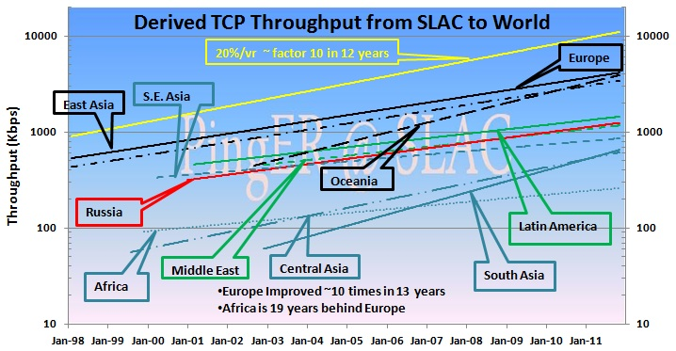
Figure 9: Derived Throughput kbits/sec from SLAC to the World (since the throughputs in this graph are not normalized we have not shown N. America). The yellow line is to help show the rate of change. If one extrapolates Europe’s performance backwards to February 1992, it intercepts Africa’s performance today.
The slow increase for Europe in Figure 8 is partially an artifact of the difficulty of accurately measuring loss with a relatively small number of pings (14,400 pings/month at 10 pings/30 minute interval, i.e. a loss of one packet ~ 1/10,000 loss rate). Looking at the data points one can see the East Asian and Oceanian trends catching Europe. Russia, Latin America and the Middle East are about 5-6 years behind Europe but are catching up. South East Asia is about 9 years behind Europe and keeping up. South Asia and Central Asia are about 12-14 years behind Europe and also keeping up. Africa as mentioned is ~ 18 years behind Europe and even worse has been falling further behind. If one extrapolates the trend lines for Africa and Europe to 10 years in the future, then at the current rate, Africa’s throughput will be 17 times worse than Europe’s. When we did this for last year’s report the difference was 30 times. The improvement from 30 to 17 is a reflection of Africa’s rate of improvement having increased with the utilization of the new terrestrial links.

View from Europe
To assist in developing a less N. American view of the Digital Divide; we added many more hosts in developing countries to the list of hosts monitored from CERN in Geneva Switzerland. We now have data going back for eight years that enables us to make some statements about performance as seen from Europe. Figure 9 shows the normalized throughput data from CERN to the rest of the world.

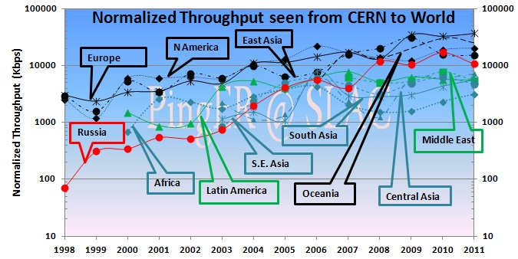
Figure 10: Normalized throughputs to various regions as seen from CERN.
As can be seen by comparing Figures 7 and 9 the general performance changes seen from CERN are very similar to those seen from SLAC.

Variability of performance between and within regions
The throughput results, so far presented in this report, have been measured from North American sites and to a lesser extent from Europe. This is since there is more data for a longer period available for the North American and European monitoring hosts. Table 4 shows more details of all the measured throughputs seen between monitoring and remote/monitored hosts in the major regions of the world. Each column is for all monitoring hosts in a given region, each row is for all monitored hosts in a given region. The cells are colored according to the median throughput quality for the monitoring region/monitored region pair. White is for derived throughputs > 10,000 kbits/s (good), green for <= 10,000 kbits/s and >5,000kbits/s (acceptable), yellow for <= 5,000kbits/s and > 1,000 kbits/s (poor), pink for <= 1000kbits/s (very poor) and > 100kbits/s red for <= 100kbits/s and > 1 kbits/s (bad), and grey for no measurements. The Monitoring countries are identified by the Internet two-character Top Level Domain (TLD). Just for the record CA=Canada, US=NET=GOV=United States, CH=Switzerland, DE=Denmark, UK=United Kingdom, AU=Australia, CN=China, HK=Hong Kong, KR=South Korea, TW=Taiwan, BO=Bolivia, MX=Mexico, IN=India, LK=SriLanka, PK=Pakistan, SU=Russia, DZ=Algeria, ZA=South Africa and BF=Burkina Faso. E. Asia includes China, Japan, South Korea, Taiwan; S. Asia is the Indian sub-continent; S.E. Asia includes Indonesia, Malaysia, Singapore, Thailand and Vietnam.
Table 3: Derived throughputs in kbits/s from monitoring hosts to monitored hosts by region of the world for November 2010. The columns are for the monitoring hosts, the rows are for the remote (monitored hosts)
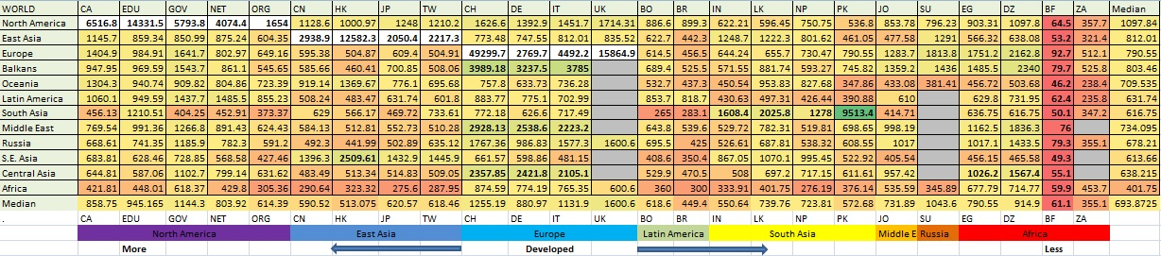
As expected it can be seen that for most TLDs (represented in columns) the best possible throughput values represented by the outlined boxes, usually exist within a region. For example for regions with better Internet connectivity, such as Europe, higher throughput is seen from European monitoring sites to TLDs (CH, DE, IT and UK) that lie within Europe. However, if the regions are close enough in terms of connectivity, throughput values are relatively higher. For example performance is better between closely located regions such as: the Balkans and European countries; Russia and E. Asia (the Russian monitoring site is in Novosibirsk); Mexico and N. America (which is better than Mexico and Latin American countries). This shows that network performance is not completely dependent on geographic proximity, but rather on how close the regions are on the map of Internet connectivity and performance. Also take for example Africa: higher throughput values are evident between Africa and the TLDs DE, IT, UK and then DZ rather than between African sites. This serves to illustrate the poor intra-regional connectivity within Africa.
This table also shows that throughput values show large variability within regions (e.g. a factor of five between Burkina Faso and Algeria). To provide further insight into the variability in performance for various regions of the world seen from SLAC, Figure 10 shows various statistical measures of the losses and derived throughputs. The regions are sorted by the median of the measurement type displayed. Note the throughput graph uses a log y-scale to enable one to see the regions with poor throughput.
It is apparent that the Interquartile range (IQR) can span one or more orders of magnitude. The most uniform region (in terms of IQR for both derived throughput and loss) is Central Asia, probably since most of the paths use a GEOS link. The most diverse are Europe and East Asia. For Europe, Belarus stands out with poor performance. For East Asia, China stands out with relatively lower performance in terms of derived throughput.

Figure 11: maximum, 95, 90, 75 percentile, median, 25 percentile and minimum derived throughputs of various regions measured from SLAC for Nov 2011 and ordered by median throughput.

Yearly Mean Opinion Score (MOS) trends
The MOS is used by the telecom industry to categorize the quality of phone calls. The MOS can be related to the loss, RTT and jitter of the circuit. With the emergence of Voice over IP (VoIP) it has become increasingly important to know what values of MOS are available on the Internet. A value of 5 is a perfect call; a value of 1 is no ability to communicate. The maximum MOS for VoIP is about 4.4. Typical values for usable VoIP are 4.2 to 3.5. Values below result in increasing frustration and inability to communicate. Figure 11 shows MOS values from SLAC to regions of the world.

It is seen that VoIP should work well from SLAC to most regions, and be usable to Central and South Asia. It is not usable for most of Africa, however with the increased deployment of terrestrial links replacing GEOS satellites, it is improving

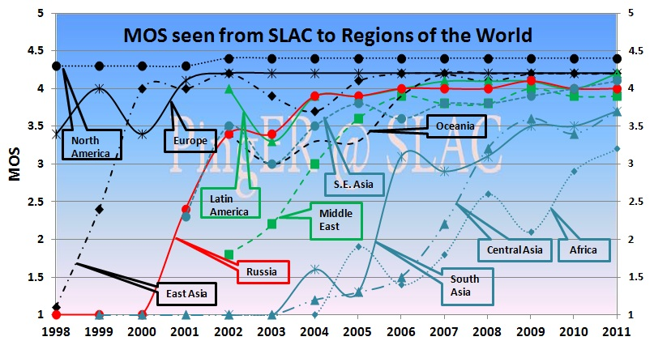

Figure 12: Mean Opinion Scores derived from PingER measurements from SLAC to regions of the world.

Comparisons with Economic and Development Indicators
The United Nations Development Program (UNDP), the International Telecommunication Union (ITU) and various other task forces are independent expert bodies which aim to provide policy advice, based on various economic factors, to governments, funding sources, and international organization for the purpose of bridging the Digital Divide. See the table below for details.
In reality, it is difficult to classify countries according to their development. The main challenges lie in determining what factors to consider, how to measure them, how useful and pervasive they are, how well defined they are, and whether they are uniformly measured for every country. Various organizations such as the ITU, UNDP, the Central Intelligence Agency (CIA), World Bank etc. have come up with Indices based on measured items such as life expectancy, GDP, literacy, phone lines, Internet penetration etc. Although many of the above challenges are not insurmountable they can require a lot of cost and time. Thus, many of these measurements are outdated and may not depict the current state of the country.
One of the most important factors determining the economic development of a country in today’s information age is its Internet connectivity. Thus we may expect moderate to strong correlations between the economy and development of a country with its Internet performance measurement. The significance of using PingER’s Internet measurements to characterize a country’s development is due to the fact that PingER’s data is current (up-to date within a day or so compared to say the most recent Information and Communications Technology (ICT) Development Index (IDI) data from the ITU that was published in 2011 and was measured in 2010) and covers most of the countries of the world. The following table shows the most commonly used indices categorized by organizations which produce them, the number of countries covered and date of the latest data.
Table 4: Economic and development indicators
Abv. | Name | Organization | No of countries | Date of Data
GDP | Gross Domestic Product per capita | CIA | 229 | 2001-2008
HDI | Human Development Index | UNDP | 182 | 2007-2009
DAI | Digital Access Index | ITU | 180 | 1995-2003
NRI | Network Readiness Index | World Economic Forum | 134 | 2008/2009
TAI | Technology Achievement Index | UNDP | 72 | 1995-2000
DOI | Digital Opportunity Index | ITU | 180 | 2004-2007
IDI | ICT Development Index | ITU | 180 | 2002-2010
OI | Opportunity Index | ITU | 139 | 1996-2003
CPI | Corruption Perception Index | Transparency Organization | 180 | 2010
From this list of indices we selected the HDI and IDI (which supersedes DOI) for further analysis and comparisons with PingER measurements because they are enriched with most of the important factors, cover a large number of countries and are reasonably up-to-date.

Human Development Index (HDI)
The UNDP HDI measures the average achievements in a country in three basic dimensions of human development:
- A long and healthy life, as measured by life expectancy at birth
- Knowledge, as measured by the adult literacy rate (with two-thirds weight) and the combined primary, secondary and tertiary education gross enrollment ratio (with one-third weight)
- A decent standard of living, as measured by GDP per capita (or Purchasing Power Parity (PPP) in US$).
Figure 13 shows a bubble plotError! Bookmark not defined. of the ITU HDI (linear y axis) versus the PingER Normalized Throughput (logarithmic x axis) for the countries of the world. The bubble size represents a country’s population, and the color represents the region for the country. The correlation coefficient R² (a measure of the strength of the linear relationship between two variables) is shown together with the line providing the best fit between the HDI and log(normalized throughput).
Table 5: R² values on correlations between PingER data vs. DOI and GDP/cap for 2008
 | Jitter (ms) | Loss (%) | Derived TCP Throughput | Unreachability
DOI | 0.58 | 0.64 | 0.67 | 0.37
GDP/capita | 0.61 | 0.53 | 0.59 | 0.35

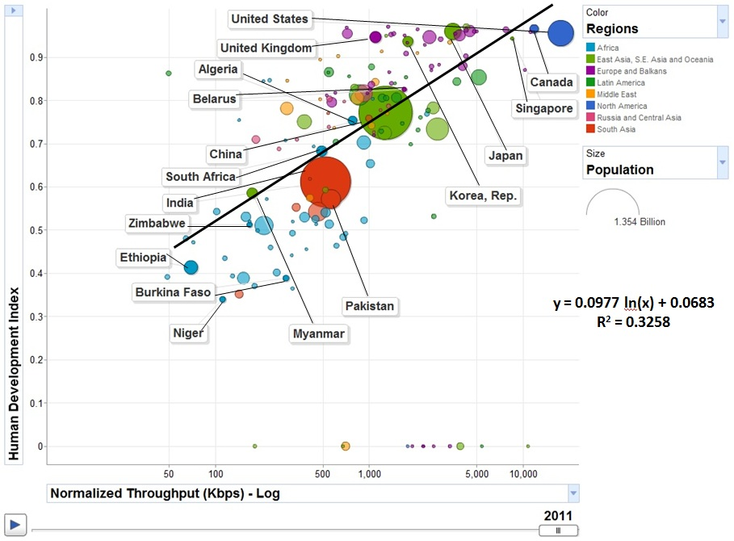
Figure 13: Comparison of PingER derived throughputs seen from N. America to various countries and regions versus the U.N. Development Program (UNDP) Human Development Indicator (HDI).

The Digital Opportunity Index (DOI)
The Digital Opportunity Index is a comprehensive metric made up of a composite of 11 core indicators that aims to track progress made in infrastructure, opportunity and utilization. If we correlate the PingER performance measurements (jitter, loss and throughput) with ITU’s indices we get a strong correlations. Strong correlations³³ are obtained with the DOI and other development indices (not shown here) that are more technology or Internet related. Table 5 summarizes the R² values which are for the correlations of PingER measurements with DOI and GDP/capita.
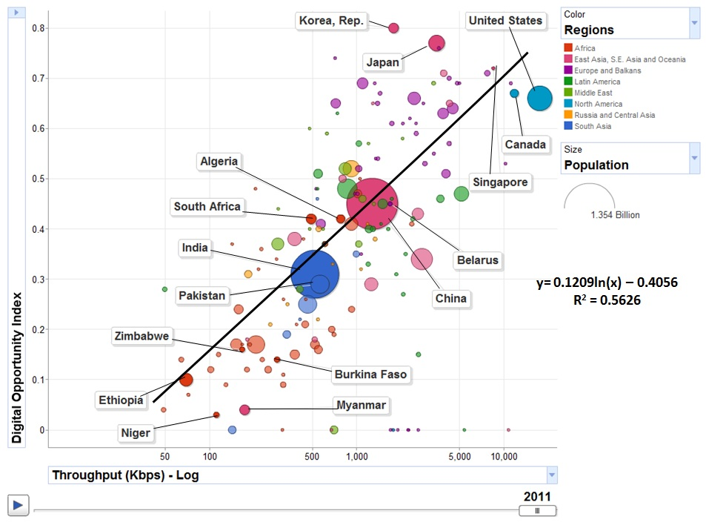
Figure 14: Throughput vs. Digital Opportunity Index.

Happy Planet Index (HPI)
The Happy Planet Index (HPI) is an index of human well-being and environmental impact that was introduced by the New Economics Foundation (NEF) in July 2006. The index is designed to challenge well-established indices of countries’ development, such as Gross Domestic Product (GDP) and the Human Development Index (HDI), which are seen as not taking sustainability into account. In particular, GDP is seen as inappropriate, as the usual ultimate aim of most people is not to be rich, but to be happy and healthy. Furthermore, it is believed that the notion of sustainable development requires a measure of the environmental costs of pursuing those goals. From Wikipedia
We downloaded the HPI data from the web and compared it with the PingER Normalized Derived Throughput for 2011. The result is seen below in the bubble plot with the bubble size being by country, and the bubble color identifying the region. To assist in distinguishing regions: European Countries are surrounded in yellow, East Asian countries are surrounded by green, and South Asian by red. The spread sheet is found here. The correlation with Internet performance is not strong. This is probably since the countries with the best Internet performance tend to the more developed ones that also consume the most resources.
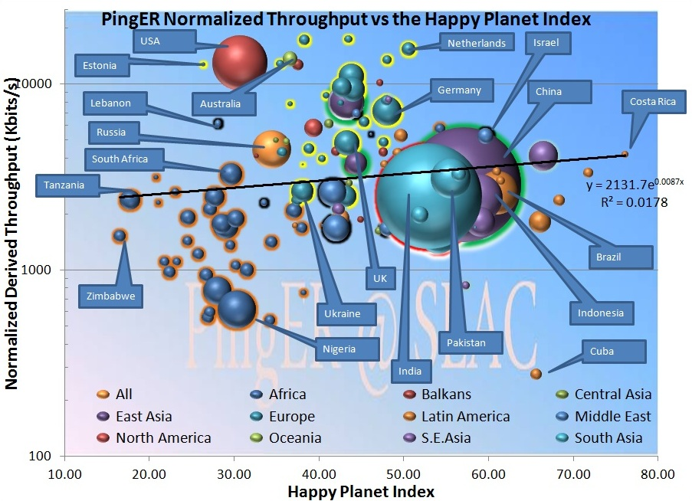
Figure 15: PingER normalized throughput versus the Happy Planet Index for 2011.
The ideal is to have high throughput and a high HPI (i.e. people live a long healthy life and the impact on the planet’s resources are minimal). Thus the closer to the top right (shaded blue) the better. It is seen that Costa Rica has the highest HPI. In general Latin American countries fare better when measured by the HPI. African countries (blue with orange surround) tend to be the worst off (i.e. in the pink regions) in throughput, happiness and offending the planet. The best developed country in terms of HPI is the Netherlands. A big offender in terms of HPI appears to be the USA with Russia and the Ukraine not far behind. On the other hand big producers like Germany and China have better HPI values.

PingER Case Studies

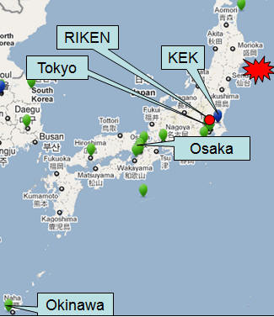
Japanese Magnitude 9.0 Earthquake 05:46 UTC March 11, 2011

Figure 16: Japanese hosts monitored from SLAC during and after the earthquake.
PingER was monitoring 6 hosts in Japan: glbb.jp in Okinawa, www.kek.jp in Tsukuba (about 43 miles NE of Tokyo); ns.osaka-i.ac.jp in Osaka; ping.riken.jp in Wako (about 10 miles NW of Tokyo), www.u-tokyo.ac.jp in Tokyo; and ns.jp-apan.jp also in Tokyo. Tokyo is about 200 miles from Sendai where the earthquake struck. The locations of the hosts is shown in Figure 15.

Internet connectivity to the 6 hosts was maintained. Round Trip Times (RTT) to some hosts increased significantly as seen from SLAC in Figure 17.

It is seen that the APAN and KEK host mean-RTTs were not affected. However the mean RTTs for the RIKEN, universities of Tokyo and Osaka hosts all increased sharply. However, as seen from the PingER monitoring host at RIKEN in Japan the mean-RTTs did not increase. Further investigation showed that monitoring hosts in Europe, S. Asia, E. Asia and the Middle East also showed no effect. It turned out the increase in RTT was caused by a cable disruption off the East coast of Japan that led to a re-routing of East-bound traffic. This was confirmed by the following quote from Telegeography on March 11, 2011:
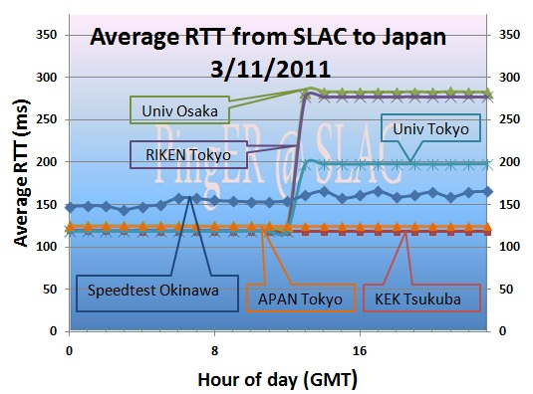
“The massive earthquake off the coast of Japan damaged several undersea cables, some of which are still awaiting repair. Despite these outages, communications between Japan and the rest of the world were largely unaffected, due to the large array of undersea cables linked to Japan. ‘The earthquake temporarily knocked out approximately 30% of Japan’s international capacity,’ according to TeleGeography Research Director Alan Mauldin. ‘The deployment of multiple new trans-Pacific cables and intra-Asian cables over the past three years proved instrumental in preventing this disaster from also disrupting communications.’”
Figure 17 Impact of earthquake on mean RTTs seen from SLAC to Japanese PingER hosts
Looking at the traceroutes from SLAC it appeared that RIKEN, KEK and the universities of Osaka and Tokyo were rerouted to SLAC via New York, while APAN used a more direct route via Sunnyvale. The longer term impact can be seen in Figure 18.
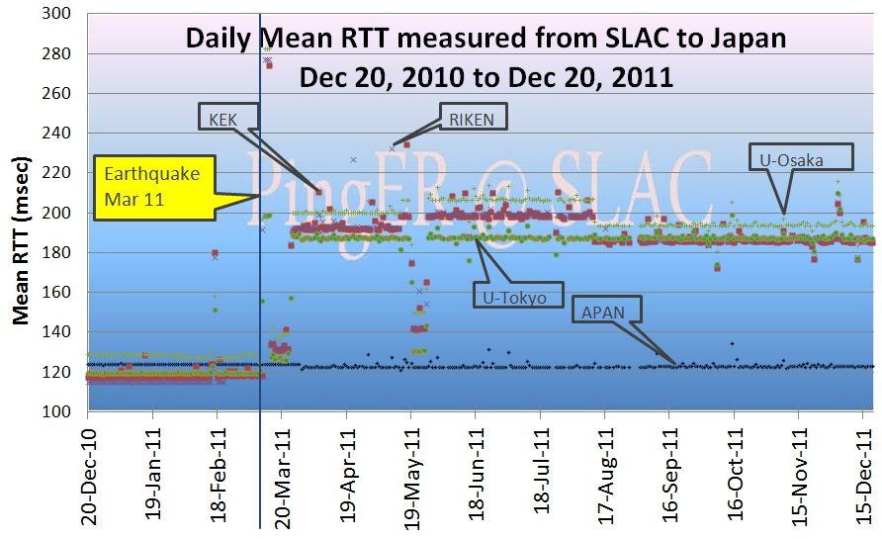
Figure 18: Daily mean RTT measured from SLAC to Japanese sites
It can be seen that before the earthquake all 5 sites had direct routes with ~ 125msec mean RTTs. APAN maintained this value, however after about a period of some instability, the other sites have settled down to permanently routing through New York with a mean RTT of ~ 190ms.

The “Arab Spring”

Tunisia
This started in Tunisia on December 18, 2010 following Mohamed Bouazizi's self-immolation in protest of police corruption and ill treatment. It led to the resignation of the President on January 14th, 2011. Though PingER connections to hosts in Tunisia were maintained throughout the uprising, there was a very obvious increase in mean RTT, see Figure 19.
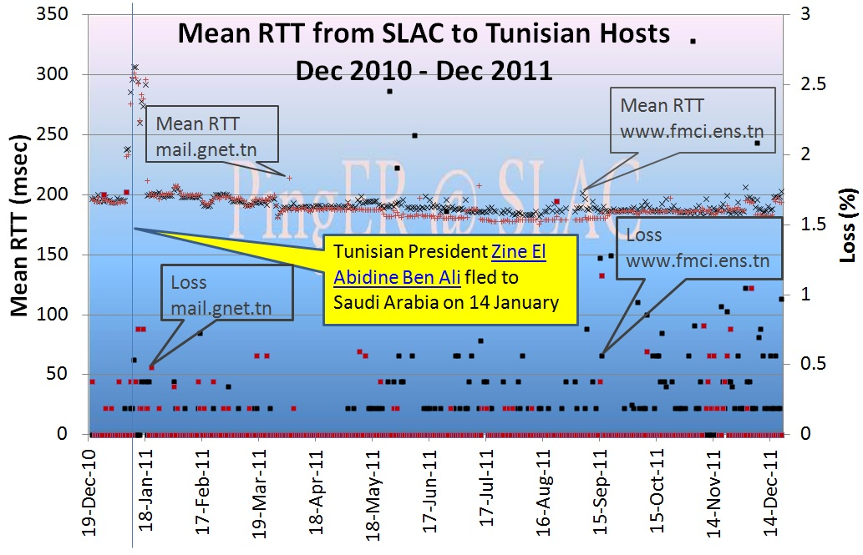
Figure 19: Mean RTT and losses to Tunisian hosts measured from SLAC from Dec 2010 to Dec 2011

Egypt
In January 2011 there were demonstrations against the Egyptian government. Organizing the demonstrations was often facilitated by using Internet to communicate. As a result, Egypt tried to cut itself off from the Internet on the 27th January, see Figure 20.
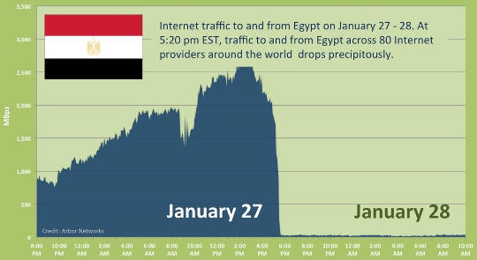
Figure 20: Egyptian traffic January 27-28 2011
As a result PingER measurements from SLAC lost connectivity to Helwan Universty at about noon Jan 27 GMT, to the National Authority for Remote Sensing and Space Science (NARSS) at about 2300hrs Jan 27 GMT and the Egyptian Universities Network (EUN) at about 4:00pm Jan 28, 2011. Similar results were observed from the PingER monitoring host at NUST in Islamabad Pakistan. On the other hand the Noor group host www.noor.net/ (AS20928, one of the major network services providers in Egypt and used by the Egyptian Stock Exchange.) was still pingable at 12:00 EST 1/30/2011, however it was no longer accessible starting after Mon, 31 Jan 2011 20:30:18 GMT.

Following the announcement that Egypt had started to restore links to the Internet, we noted that www.noor.net was again reachable sometime after 10:30:00 and before 11:00:32 Wed, 02 Feb 2011 GMT. Figure 21 shows the unreachability of NARRS.
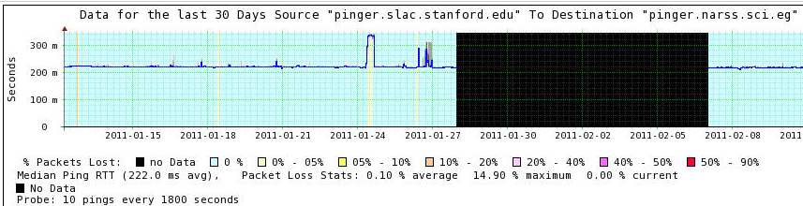
Figure 21: Median RTT (blue) line from SLAC to NARRS Jan-Feb 2011 showing the loss of connectivity. The grey show the jitter, and the background color the loss (cyan = no loss, buff = < 5% loss, black host is unreachable).
It is noteworthy that as far as we could ascertain the Biblioteka Alexandria or Library of Alexandra host www.bibaex.org stayed up the whole time.

Libya
The three Libyan hosts monitored by PingER at the start of the Libyan uprising were all located in or close to Tripoli. We began to see outages for all hosts starting in March 2011. The most reliable host appeared to be Libyan Telecom host mail.lttnet.ly. It was unreachable at the start of March and stayed unreachable until the middle of April, see Figure 22.
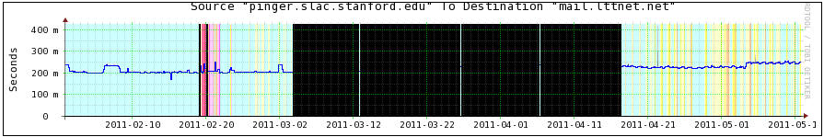
Figure 22: PingER measurements to the LTTNET host in Libya

When one looks at the performance for the whole year (see Figure 23) it is clear that the LTT host is the most reliable. It is also apparent that the Airport Reservations host (HN) moved to a portal in the US with a much shorter RTT.

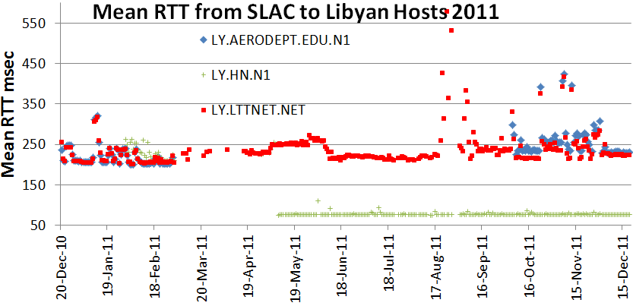
Figure 23" Mean RTTs seen from SLAC to Libyan hosts in 2011.

It is very difficult to find suitable hosts to monitor in Syria. The node we have monitored all year is www,inet.sy. Apart from a brief (< 1 day) period of unreachability it has stayed up all year with a pretty consistent mean RTT.

We also studied hosts monitored in Algeria, Bahrein and Morocco, but were unable to see any marked impacts caused by the unrest.

Pakistan Education and Research Network
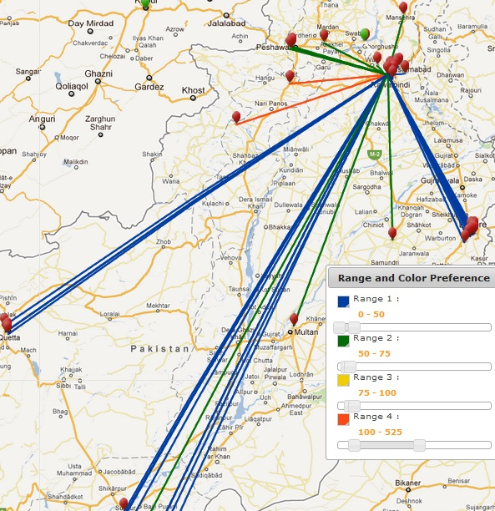
Over the last year, following a series of meetings and site visits, the team at NUST and SLAC has worked with Pakistan’s Education and Research Network (PERN) and Pakistani Universities to put together an end-to-end (E2E) network monitoring infrastructure for PERN connected higher education sites. So far they have installed the PingER monitoring tools and started gathering data at 55 sites in Pakistan. This includes 4 sites (SEECS/NIIT, COMSATS, PERN and NCP/Quaid-i-Azam) which have been in place for a longer time. All these nodes are actively monitoring other nodes, except a few which have power or network issues.
Figure 24: Locations of PingER hosts in Pakistan. The red hosts are monitors, the green are monitored (remote) hosts. The lines show the hosts monitored from the NUST host in Islamabad. The colors of the lines indicate the average RTT in msec.

In 2010, a second instance of the SLAC archive-analysis site was set up at NUST. This provides backup for data and access, and improved performance for Pakistani users.

Over the last year the number of monitoring host – remote host pairs (both in Pakistan) has increased from about 200 to over 1500. From the data we have put together a case study and are able to measure minimum and average Round Trip Times (RTT), jitter, loss, unreachability and derive throughput, directness of connections, and Mean Opinion Score (MOS).
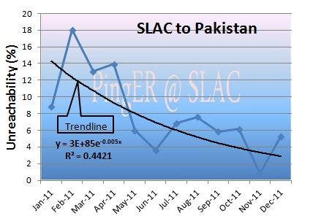
A major concern has been the reliability of the monitoring hosts. We measure this using the unreachability metric. The unreachability of the Pakistani PingER hosts in 2010 is shown in Figure 25.

The reasons behind the high unreachability are usually site specific and vary from lack of reliable power and a source of backup power, floods, lack of access to the site when there are problems that require physical access, lack of expertise, and lack of interest from a site.
Figure 25 Unreachability of Pakistani hosts seen from SLAC

As seen in the Figure, unreachability has reduced from about 14% to about 3% in past year. This was made possible by the help of Higher Education Commission of Pakistan who ensured the provision of uninterrupted power supplies to POP nodes. There are a total of 14 POP nodes in Pakistan with at least 1 POP node in each of the 5 regions of Pakistan.

A series of detailed analyses has been carried out to find out the inter regional and intra-regional POP to POP and POP to Non POP performance so as to take effective steps for further improvements.

The PERN network has improved the reliability within Pakistan. It is observed³⁸ that all the nodes on PERN have lower RTTs compared to the nodes which are not on PERN. This results in higher throughputs (since throughput goes as 1/RTT).

Figure 26 shows that, seen from SLAC, in the last year there has been a small improvement (30%) in the throughput and the packet loss has reduced by roughly a factor of 2.
Figure 26 throughput and Packet losses seen from SLAC to Pakistan

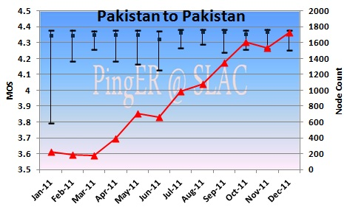
The derived throughput between SLAC and Pakistan has been observed to increase by roughly a factor of 2 in 5 years³⁸. Within Pakistan the throughput to Quetta is the poorest, followed by Karachi³⁸. The Karachi region has high RTTs while accessing other hosts in the Karachi region; this is due to unreliable network conditions due to the floods and after effects. In the Quetta region power is the major issue for hosts being unreachable. However, when the hosts are up throughput values prove that network is working well enough for a reliable VOIP connection. As the number of hosts in Islamabad increased, an increase in RTT has also been observed due to high traffic generated and consequent congestion³⁸.
Figure 27 Median MOS and Inter Quartile Range (IQR) between Pakistani hosts for 2011.

The MOS between the Pakistani PingER hosts is shown in the Figure 27. It is apparent that the MOS is very stable throughout the year with median MOS values ranging 4.35-4.37 (all in an excellent range for VOIP). This also shows that the MOS did not decrease with bringing on new hosts, mainly because the new hosts were all on PERN. All the year the MOS is well above the typical range for VoIP. Thus VoIP calls within Pakistan between these hosts should be successful.

To evaluate the directness of connectivity between Pakistani hosts we use the alpha metric. Figure 28 shows the alpha values between regions in Pakistan. It is based on the minimum RTTs seen between Jan 2011 and Dec 2011.
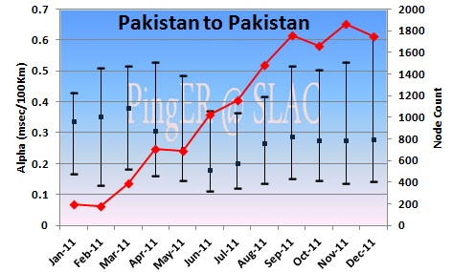
It is seen that as new nodes were added, alpha decreased due to increased minimum RTTs. The reduction in alpha is indicative of less direct routes. A change in routes is also observed in the last quarter of the year³⁸. Investigation of alpha for the links between Karachi and Lahore, Karachi and Islamabad, and Karachi and Peshawar yield values of alpha close to one (i.e. very direct) and are also very consistent (low values of the standard deviations). Islamabad is connected indirectly to other cities (low value of alpha). Prior to September 2011 routes from Islamabad to Quetta, or to Lahore, or to Peshawar, went via Karachi in the South and then back northward. Also the links between Lahore and Peshawar also went via Karachi. Since September 2011 routing between all regions (Islamabad, Karachi, Lahore, Peshawar, and Quetta goes via Islamabad. Hence, this leads to higher minimum RTTs, lower alphas, and less direct routes between Karachi, Lahore, Peshawar, and Quetta.
Figure 28: Average Alpha measured between regions of Pakistan with the standard deviations (as error bars) and the number of host pairs contributing to the measurement.

High Performance Network Monitoring

New and Ongoing Monitoring and Diagnostic Efforts in HEP
PingER and the now discontinued IEPM-BW are excellent systems for monitoring the general health and capability of the existing networks used worldwide in HEP. However, we need additional end-to-end tools to provide individuals with the capability to quantify their network connectivity along specific paths in the network and also easier to use top level navigation/drill-down tools. The former are needed both to ascertain the user's current network capability as well as to identify limitations which may be impeding the user’s ultimate (expected) network performance. The latter are needed to simplify finding the relevant data. The perfSONAR project has grown to fill this need and we will show later how it is being leveraged to address the needs of the LHC community.
Most HEP users are not "network wizards" and don't wish to become one. In fact as pointed out by Mathis and illustrated in Figure 19, the gap in throughput between what a network wizard and a typical user can achieve was growing significantly from the late 1980’s to the late 1990’s
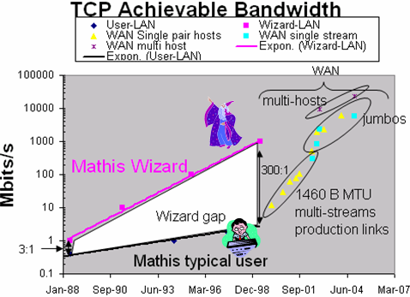
Figure 29: Bandwidth achievable by a network wizard and a typical user as a function of time. Also shown are some recent network throughput achievements in the HEP community.

Within the last 15 years, because of improvements in default OS TCP stack settings, new protocols, hardware, firmware and software, this gap has decreased but still remains. Because of HEP's critical dependence upon networks to enable their global collaborations and grid computing environments, it is extremely important that more user specific tools be developed to support these physicists and continue to decrease the gap between what an expert can achieve and what a typical user can get “out of the box”.
Efforts continue in the HEP community to develop and deploy a network measurement and diagnostic infrastructure which includes end hosts as test points along end-to-end paths in the network. This is critical for isolating problems, identifying bottlenecks and understanding infrastructure limitations that may be impacting HEP’s ability to fully utilize their existing networks. Originally the E2E piPEs project, the NLANR/DAST Advisor project and the LISA (Localhost Information Service Agent) initiated developing an infrastructure capable of making on demand or scheduled measurements along specific network paths and storing test results and host details for future reference in a common data architecture. Since 2008 the perfSONAR project has become the organizing entity for these efforts and is broadly supported (see below). The perfSONAR effort is utilizing the GGF NMWG schema to provide portability for the results. This information can be immediately used to identify common problems and provide solutions as well as to acquire a body of results useful for baselining various combinations of hardware, firmware and software to define expectations for end users. In addition the perfSONAR-PS distribution includes many of the tools (PingER, NDT, Advisor, Iperf, traceroute server etc) which are the recognized standards in network testing and diagnosis
Efforts to ensure commonality in both monitoring and provisioning of networks are continuing The GLIF and DICE communities are both working toward implementing “managed” network services and the corresponding monitoring that will be needed to support their efforts. HEP (US LHCnet, the various HEP network research projects and the national labs) is working within these groups to insure our needs are being addressed.
A primary goal is to provide as "lightweight" a client component as possible to enable widespread deployment of such a system. The LISA Java Web Start client is one example of such a client, and another is the Network Diagnostic Tester (NDT) tool. By using Java and Java Web Start, the most current testing client can be provided to end users as easily as opening a web page. The current NDT version supports both Linux and Windows clients and is being maintained by Rich Carlson (formerly Internet2, now DOE). In addition to inclusion in perfSONAR, the typical network client tools (NDT and NPAD) are now included in the Open Science Grid (OSG) software distributions since v2.0.0. This allows easy access to these diagnostic tools wherever OSG is deployed.
The goal of easier-to-use top-level drill down navigation to the measurement data is being tackled by the USATLAS group. During fall of 2010 additional service monitoring capabilities were added with a package of Nagios “plugins” which allows detailed monitoring of perfSONAR services and test results. Tom Wlodek at BNL has been working closely with the USATLAS Throughput working group in developing a set of service and measurement tests that can be tracked in customized server pages setup at BNL. The software has been modularized and is in use by the Italian, Canadian and US “clouds” as well as the LHCOPN and LHCONE efforts. Some details will be shown later in this section.
The US ATLAS collaboration has made an extensive effort to improve the throughput of their Tier-1 and Tier-2 centers and has coupled this with active testing and monitoring to track performance over time. Bi-weekly meetings of the USATLAS Throughput working group focus on throughput, network measurements and related site issues. During 2011 we expanded the Throughput meetings to include representatives from the ATLAS Canadian cloud. This group is working in two primary areas: 1) automated transfer throughput testing using ATLAS production systems and 2) deployment and integration of perfSONAR at all USATLAS Tier-2 sites and the Tier-1 site at Brookhaven. We will discuss perfSONAR deployment and experience in USATLAS in the next section and will focus on the automated (and manual) throughput testing USATLAS is using here.
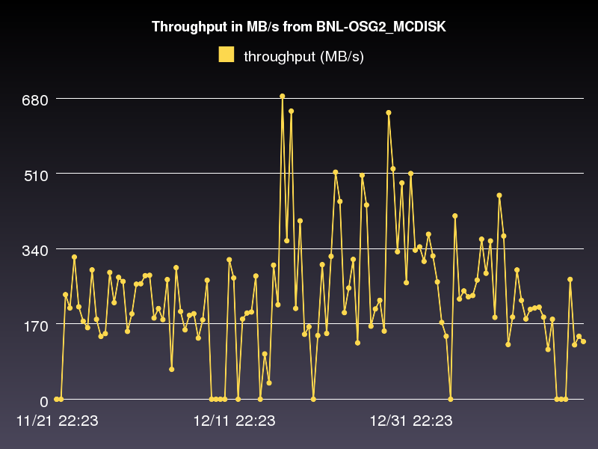
Figure 30 Example production system throughput test results between two USATLAS sites: BNL (Tier-1) and AGLT2 (Tier-2). Shown are the storage areas: AGLT2_DATADISK and BNL_OSG2_MCDISK from November 21, 2011 to January 20, 2012
The perfSONAR infrastructure is intended to measure the network (LAN,WAN) between perfSONAR test nodes but this is not sufficient to characterize the “end-to-end” behavior of the distributed systems in use in HEP. The USATLAS throughput group has developed some additional automated (and manual) tests to accurately measure their system capabilities and limits. Hiro Ito (BNL) has developed an automated data transfer service which sends a fixed number of files between sites using the standard ATLAS production system and records the results. Results of these tests are available at http://www.usatlas.bnl.gov/dq2/throughput where you can find details on the number of successful transfers, their throughput and timing. One example graph is shown in Figure 16 which shows test dataset transfer throughput between Brookhaven (Tier-1) and AGLT2 (Tier-2). During 2009-10, the system was extended to include Tier-2 to Tier-3 tests (in addition to the standard Tier-1 to Tier-2 tests originally defined). These results, in combination with perfSONAR results, are being used to identify problems in the overall system and isolate their likely location. We made significant progress on our goal for 2011 targeting use of the production system results and the perfSONAR results during the same time periods to more accurately localize any problems that may arise. For 2012 we intend to focus on improving the integration and analysis of the data provided to more quickly identify and localize network problems in the infrastructure.
In addition to automated testing USATLAS has setup manual “Load Tests” designed to characterize the maximum transfer capability between sites. A “Load Test” TWiki page at http://www.usatlas.bnl.gov/twiki/bin/view/Admins/LoadTests has further details on some initial tests. One of the milestones of the USATLAS throughput group was achieving 1 GigaByte/sec from the Tier-1 to a set of Tier-2’s. This was first demonstrated in October 2009 and is shown in Figure 31. Individual Tier-2’s with 10 gigabit Ethernet connectivity were also individually validated as being able to achieve at least 400 MBytes/sec in early 2010 as an additional milestone. As of 2011 we have vetted all our 10GE connected Tier-2 centers as being capable of meeting this benchmark.
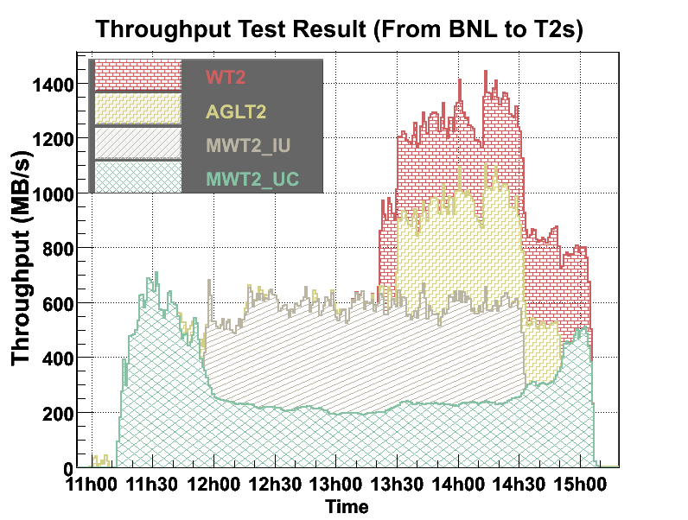
Figure 31: First USATLAS Throughput milestone (1GB/sec for 1 hour)

perfSONAR in USATLAS
As mentioned above, most HEP users are not interested in becoming network wizards nor do they have the expertise to diagnose network related problems. Within USATLAS a significant effort has been made to deploy and integrate perfSONAR at all Tier-1/Tier-2 sites in the US to provide a standardized set of tools and corresponding network measurements to aid in problem isolation and diagnosis as well as for baseline monitoring. The plan for USATLAS has been to deploy two perfSONAR instances (each on their own, identical hardware) at each distinct Tier-2 site (as well as the Tier-1 at BNL). We achieved a complete production-ready state in fall of 2010 using the V3.2 release of perfSONAR-PS provided by Internet2 and ESnet. As of fall 2011 we had upgraded all sites to V3.2.1.
Since many USATLAS Tier-2’s are physically distributed at more than one location, more than 2 systems per Tier-2 are deployed. It was important that all sites deploy identical hardware to remove hardware variations that might impact measurements. An inexpensive system with two 1GE onboard NICs (~$635) from KOI computing was identified in fall 2008 and has been deployed at 8 Tier-2 sites and BNL. Two systems per site are required to allow both throughput and latency tests to be undertaken which would interfere with each other if they ran on the same system. Since these systems were purchased, some issues with the particular 1 GE NIC and hard-disk controller have been identified and Internet2 has created new recommendations for future perfSONAR-PS purchases. During 2010 the University of Michigan purchased a Dell R410 system as a possible “integrated” hardware node intended to run both latency and bandwidth tests from a single system. This node has been made available to the perfSONAR-PS developers and we had hoped to have a perfSONAR-PS deployment capable of utilizing this hardware sometime in 2011. Unfortunately not as much progress was made in this area as we had hoped. During 2011 we evaluated Dell R310 systems in the US and Dell R610 systems in Canada as possible hardware replacements for the aging KOI systems. Dell agreed to provide LHC pricing for “perfSONAR-PS” systems on their LHC portal and as of January 1, 2012, two versions (R310 and R610 based) are available. The Canadian Tier-1 and Tier-2 centers have deployed the R610 version and the US centers plan to deploy upgraded 10GE capable latency boxes in the first quarter of 2012.
The perfSONAR systems in USATLAS are intended to run full-mesh tests for both throughput and latency with all other USATLAS Tier-2’s and the Tier-1. The latency role is assigned to the first node (typically designated with a ‘1’ in the DNS name) by convention while the throughput role is assigned to the second node. Installation is made straightforward by simply booting a recent ISO image provided by Internet2 and doing a one-time configuration of the node. Configuration results as well as measurements are persisted onto the local hard-disk of the system being configured.
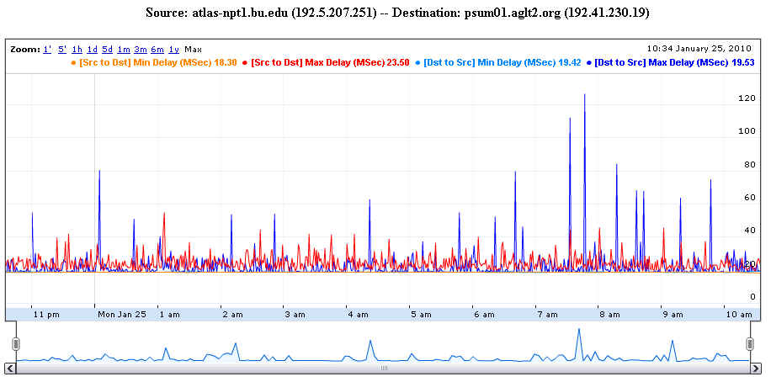
Figure 32: Example OWAMP test between two USATLAS Tier-2's (bi-directional testing is enabled)

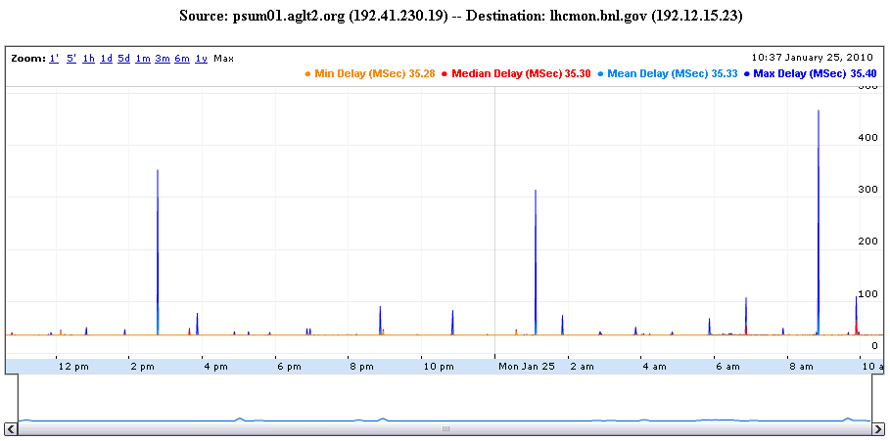
Figure 33: Example PingER graph between the Tier-1 and a Tier-2

The latency tests have two variations. The first is managed by OWAMP and measures one-way delays between the latency node and its test partner at another site. Since absolute time accuracy is critical for this test, part of a latency node configuration includes setting up a reliable time service (ntpd) configuration to ensure the node keeps accurate time. The second type of latency test is provided by PingER which is configured by default to send 600 ping packets per minute between the latency node and its target and track the results. Examples of both types of tests are shown in Figure 32 and Figure 33.

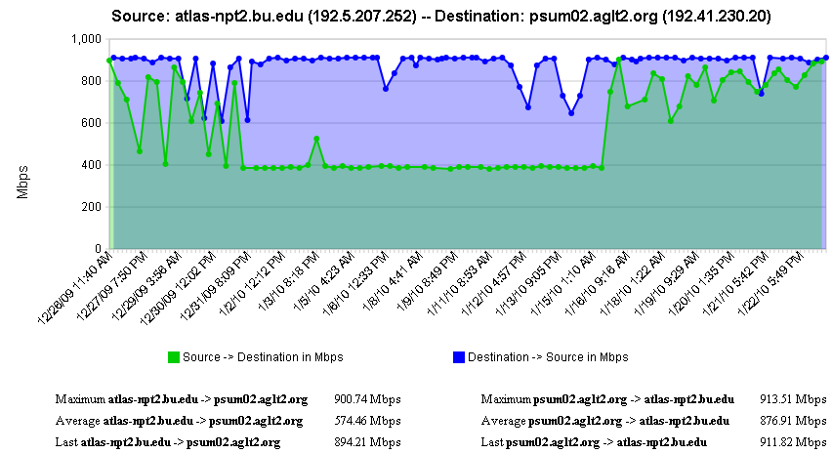
Figure 34: Example bi-directional throughput test in perfSONAR between two Tier-2s

The second perfSONAR node measures throughput using Iperf. Example results are shown in Figure 34 which illustrates some interesting throughput changes during the 1 month of measurements shown.
As of the perfSONAR-PS vv3.2.1 release we have an additional test that we are configuring: traceroute. The new version has the ability to track the traceroute path between the host and any destination specified. The default is to check each destination every 10 minutes. If the route changes, we record the new route in the perfSONAR-PS measurement archive. This allows us to better understand the topology we are measuring and can alert us to routing changes that may be correlated with observed network problems.
Incorporating perfSONAR into USATLAS “operations” began starting in fall 2010. The Throughput working group is incorporating the Nagios plugins mentioned above to track both the perfSONAR infrastructure (verifying services continue to be operational) and validating the resulting network measurements. One issue that became clear early on this process was that requiring sites to setup and configure Nagios may be too heavyweight. Tom Wlodek then provided a modular “standalone” dashboard code-base that would allow sites to more easily enable setting up a monitoring interface using the plugins provided by ESnet (originally for Nagios). Our goal is to have the system alert sites when there are significant changes in network behavior so problems can be quickly found and fixed. An example of the new modular service dashboard is shown in Figure 35 below.
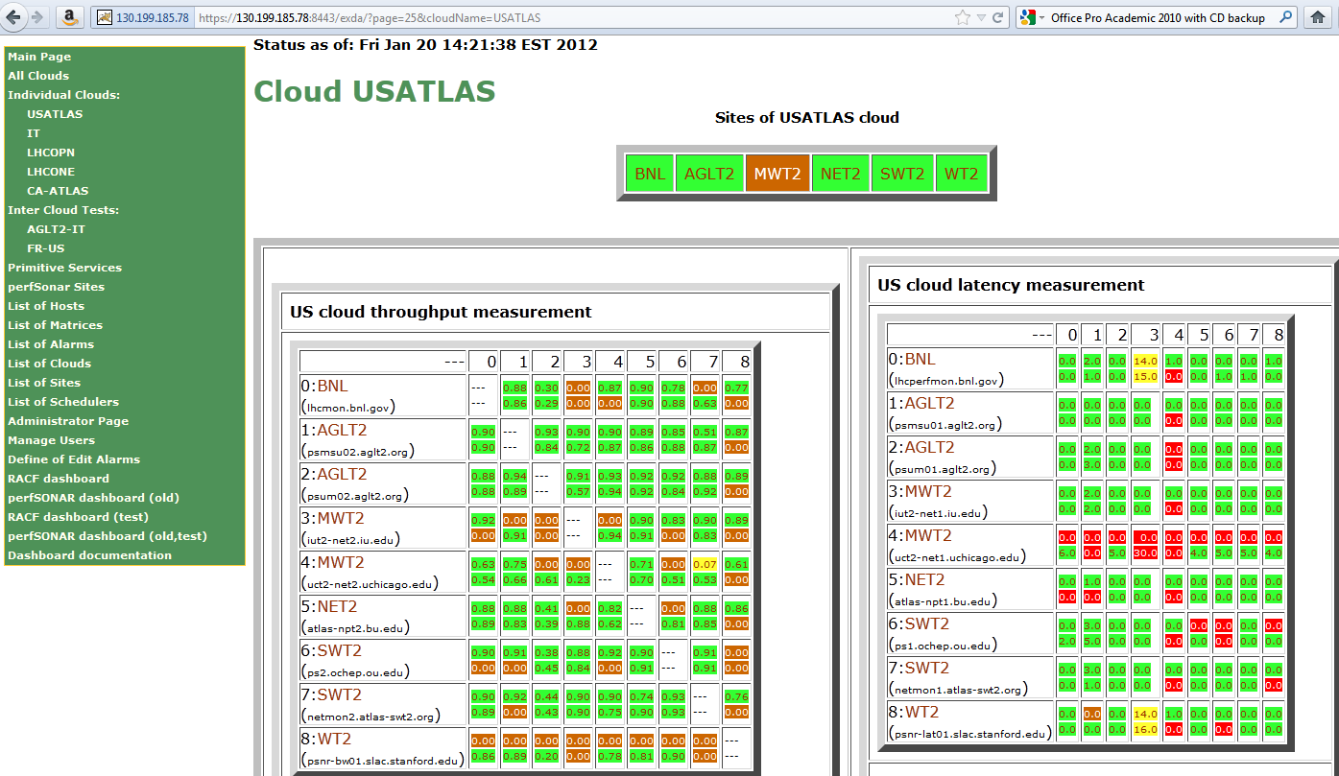
Figure 35 Example perfSONAR monitoring using the BNL modular dashboard. The detailed status of perfSONAR services can be tracked and alerts of problems automatically sent. Results are color-coded with green meaning “OK”, brown indicating “UNKNOWN” status, yellow “WARNING” and red “PROBLEM”.
The USATLAS group has provided important feedback to the perfSONAR distribution developers and has identified a number of bugs which impact the reliability and usability of the distribution. Once a sufficiently robust distribution is identified USATLAS plans to recommend broader perfSONAR deployment to include Tier-3 sites. Having a perfSONAR instance at Tier-3’s can help compensate for the lack of manpower and expertise at these sites and allow remote experts access to necessary information for diagnosing network or end-site issues. As of v3.2.1 (released in October 2011) we have achieved a level of robustness that may allow us to recommend broad deployment of perfSONAR to Tier-3 sites in 2012.
It should also be noted that having perfSONAR services running co-located with important resources provides the ability to run “on-demand” tests using the broadly deployed NDT and NPAD tools. These tools can be run from any remote location, testing to any perfSONAR instance. This is a very important additional capability that can be vital in network diagnosis.
perfSONAR is already broadly deployed in Research and Education network PoPs (Internet2, GEANT2, ESnet) and it is hoped that more collaborations within HEP will deploy perfSONAR instances co-located with their computing and storage resources. Having a more extensive deployment significantly improves the value and applicability of the overall perfSONAR infrastructure for HEP.

LHCOPN Monitoring
During the last few years there has been a concerted effort to deploy and monitor the central data distribution network for the Large Hadron Collider (LHC). This network, dubbed the LHCOPN (Optical Private Network), has been created to primarily support data distribution from the CERN Tier-0 to the various Tier-1’s worldwide. In addition, traffic between Tier-1 sites is also allowed to traverse the OPN.
Given the central role this network will play in the distribution of data, it is critical that this network and its performance be well monitored. A working group was convened in fall of 2005 to study what type of monitoring might be appropriate for this network. A number of possible solutions were examined including MonALISA, IEPM-BW/PingER, various EGEE working group efforts and perfSONAR.
By spring of 2006 there was a consensus that LHCOPN monitoring should build upon the perfSONAR effort which was already being deployed in some of the most important research networks. perfSONAR is a standardized framework for capturing and sharing monitoring information, other monitoring systems can be plugged into it with some interface “glue”.
During 2007 a newly created organization named the E2ECU (End to End Coordination Unit), operated by the GEANT2 NOC, started using perfSONAR tools to monitor the status of almost all the circuits in the LHCOPN.
DANTE has proposed and deployed a no-cost managed network measurement service to the LHCOPN community to perform significantly more robust measurement of the LHCOPN, including active latency & bandwidth tests, link utilization, etc all based on perfSONAR tools & protocols. This deployment was completed in early 2010 and is being used to track the system of the LHCOPN and its performance.
During the June 2011 meeting of the LHCOPN, it was decided to immediately deploy perfSONAR-PS at all LHCOPN Tier-1 sites and CERN, primarily because of the success USATLAS had in building the modular dashboard to monitor and augment their perfSONAR-PS deployment. By September 2011 all LHCOPN sites had perfSONAR-PS installed and configured. Below in Figure 36 is the current status of the LHCOPN monitoring:
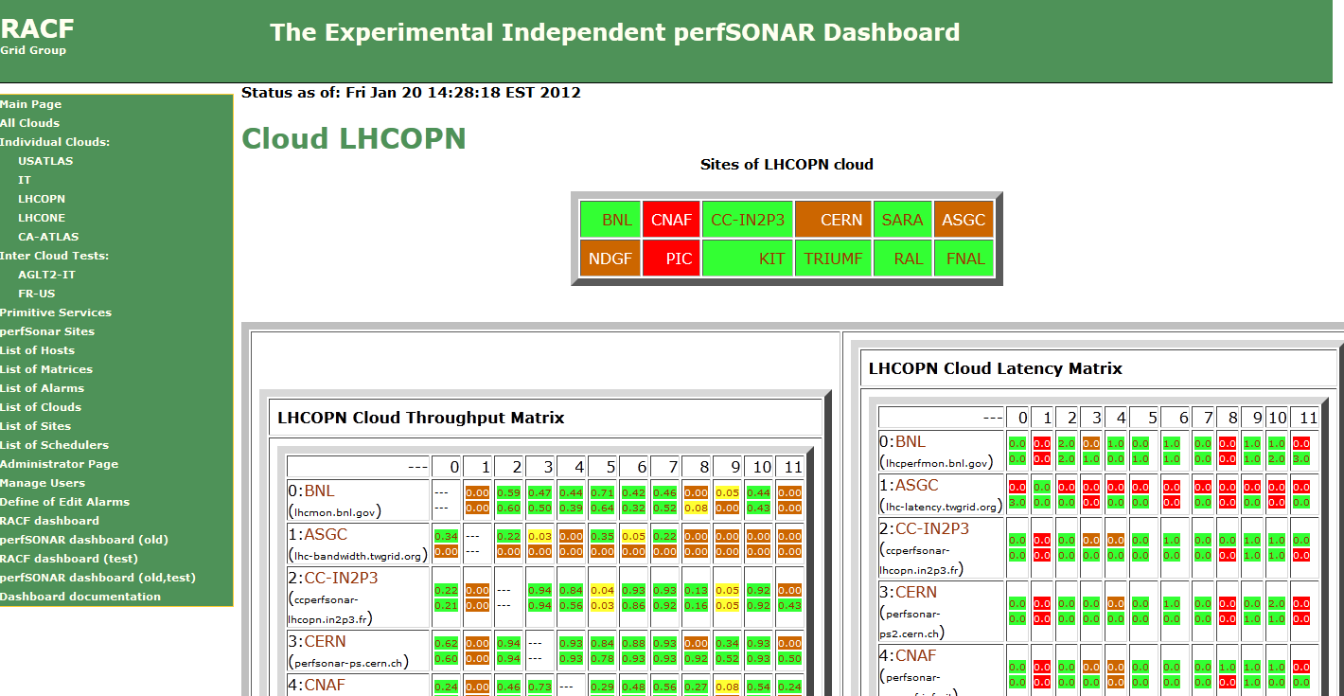
Figure 36: A snapshot of the modular dashboard showing the LHCOPN perfSONAR-PS measurement status

LHCONE
Discussions about extending LHC networking beyond the Tier-0/Tier-1 centers started during an LHCOPN meeting in the summer of 2010. By January 2011 there was a plan in place to begin deploying a prototype “network” called LHCONE. The goal for LHCONE was both to provide Tier-n LHC sites better networking and to more easily allow the backbone and regional networks to manage and support LHC networking needs. One requirement for LHCONE was to not impact the successful and operational LHCOPN.
As sites started to test the prototype architecture for LHCONE, it quickly became clear that we needed a way to monitor this new infrastructure. In fall 2011 we decided to setup perfSONAR-PS monitoring for LHCONE sites. We leveraged the existing modular dashboard to track the LHCONE network that was used for the various ATLAS clouds and the LHCOPN. Shown in Figure 37 is an example of the LHCONE monitoring matrices for bandwidth and throughput setup on the BNL modular dashboard.
The initial monitoring goal for LHCONE is to measure the current network performance between all the candidate LHCONE early adopter sites to set a baseline. Then, as sites join LHCONE, we can use the ongoing measurements to document how the networking between sites changes as LHCONE is adopted.
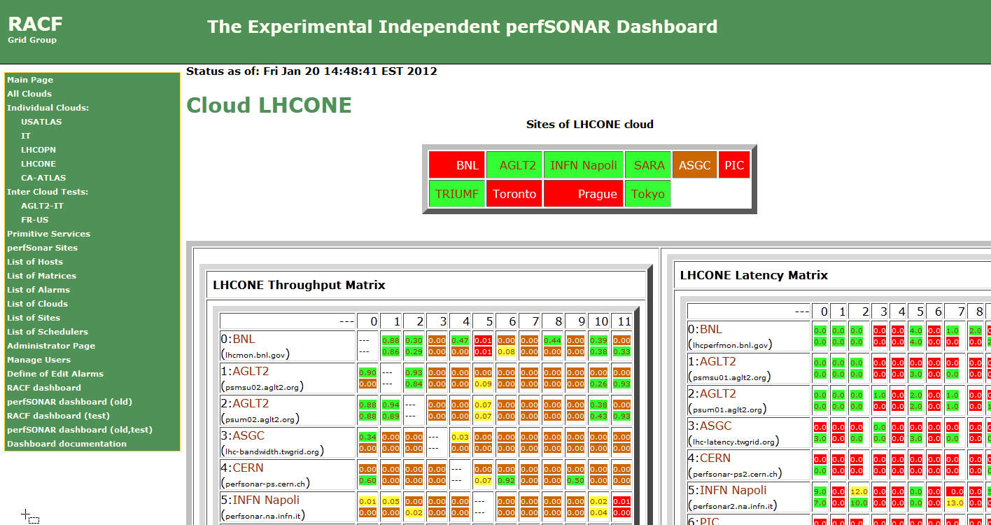
Figure 37: The prototype LHCONE monitoring page showing the early setup for monitoring. The URL is https://perfsonar.usatlas.bnl.gov:8443/exda/?page=25&cloudName=LHCONE

Related HEP Network Research
There has been a significant amount of research around managed networks for HEP that we should note. There are efforts funded by the National Science Foundation (UltraLight (finished Aug 2009), PLaNetS) and Department of Energy (Terapaths (finished Dec 2009), LambdaStation (finished 2009), OSCARS, and the associated follow-on projects StorNet and ESCPS projects) which are strongly based in HEP. These projects are not primarily focused upon monitoring but all have aspects of their efforts that do provide network information applications. Some of the existing monitoring discussed in previous sections either came out of these efforts or is being further developed by them.
In summer 2010 a new NSF MRI project was funded called DYNES. The DYNES collaboration (Internet2, Caltech, Michigan and Vanderbilt) intends to create a virtual distributed instrument capable of creating dynamic virtual circuits on-demand between the participating member sites. The LHC community and its data access and transport requirements are the primary “users” targeted by this new infrastructure. Funding was provided to initially deploy DYNES at 40 institutions and 14 regional networks within the United States. DYNES intend to leverage prior work related to virtual circuit construction, QoS and perfSONAR to enable the required capabilities. Instrument deployment began in spring 2011 and should complete in the first quarter 2012. The DYNES project has a 3 year lifetime and a goal of transitioning the DYNES distributed instrument into production use by its members by the end of the project.

Comparison with HEP Needs
Previous studies of HEP needs, for example the TAN Report (http://gate.hep.anl.gov/lprice/TAN/Report/TAN-report-final.doc) have focused on communications between developed regions such as Europe and North America. In such reports packet loss less than 1%, vital for unimpeded interactive log-in, is assumed and attention is focused on bandwidth needs and the impact of low, but non-zero, packet loss on the ability to exploit high-bandwidth links. The PingER results show clearly that much of the world suffers packet loss impeding even very basic participation in HEP experiments and points to the need for urgent action.
The PingER throughput predictions based on the Mathis formula assume that throughput is mainly limited by packet loss. The 20% per year growth curve in Figure 9 is somewhat lower than the 79% per year growth in future needs that can be inferred from the tables in the TAN Report. True throughput measurements have not been in place for long enough to measure a growth trend. Nevertheless, the throughput measurements, and the trends in predicted throughput, indicate that current attention to HEP needs between developed regions could result in needs being met. In contrast, the measurements indicate that the throughput to less developed regions is likely to continue to be well below that needed for full participation in future experiments.

Recommendations
There is interest from ICFA, ICTP, IHY and others to extend the monitoring further to countries with no formal HEP programs, but where there are needs to understand the Internet connectivity performance in order to aid the development of science. Africa is a region with many such countries. The idea is to provide performance within developing regions, between developing regions and between developing regions and developed regions.
We should ensure there are >=2 remote sites monitored in each Developing Country. All results should continue to be made available publicly via the web, and publicized to the HEP community and others. Typically HEP leads other sciences in its needs and developing an understanding and solutions. The outreach from HEP to other sciences is to be encouraged. The results should continue to be publicized widely.
We need assistance from ICFA and others to find sites to monitor and contacts in the developing and the rest of the world, especially where we have <= 1 site/country. A current list of countries with active nodes can be found at http://www-iepm.slac.stanford.edu/pinger/sites-per-country.html.

Future Support
Although not a recommendation, it would be disingenuous to finish without noting the following. SLAC, SEECS-NUST & FNAL are the leaders in the PingER project. The funding for the PingER effort came from the DoE MICS office since 1997, however it terminated at the end of the September 2003, since it was being funded as research and the development is no longer regarded as a research project. From 2004 onwards, development was continued with funding from the Pakistani Higher Education Commission (HEC) and the US State Department. Further funding for this research collaboration -- between SLAC and NUST -- was acquired from HEC for four years i.e. 2008-2011. This funding is primarily used for human resource development i.e. providing opportunities for graduating students to work at SLAC and participate in the research and development activities. The development consists of extending and enhancing the project, fixing known non-critical bugs, improving visualization, automating reports generated by hand today, finding new country site contacts, adding route histories and visualization, automate alarms, updating the web site for better navigation, adding more Developing Country monitoring sites/countries, and improve code portability. The daily management, operation and supervising/leading the development was continued with discretionary funding from the SLAC and FNAL HEP programs. The management and operation includes maintaining data collection and archiving, explaining needs, identifying and reopening broken connections, identifying and opening firewall blocks, finding replacement hosts, making limited special analysis and case studies, preparing and making presentations, responding to questions. The equipment performing this is currently in place at both SLAC and FNAL. Management, operation and supervision require central funding at a level of about 15% of a Full Time Equivalent (FTE) person, plus travel. This has been provided by discretionary funding from the HEP budgets of SLAC and FNAL. The 2008 cuts in the US science budget, the impact on the Department of Energy, HEP and SLAC have meant that SLAC no longer has discretionary funding and has thus no longer officially supports the Digital Divide activities. Without funding, for the operational side, the future of PingER and reports such as this one is unclear, and the level of effort sustained in previous years will not be possible. The work this year was accomplished with funding from Pakistan to support the students and pro-bono support from SLAC. Many agencies/organizations have expressed interest (e.g DoE, ESnet, NSF, ICFA, ICTP, IDRC, UNESCO, IHY) in this work but none have so far stepped up to funding the management and operation.

Acknowledgements
We gratefully acknowledge the following: the assistance from NUST SEECS in improving the PingER toolkit and management has been critical to keeping the project running, with respect to this we particularly acknowledge the support of their leader Arshad Ali; and the students and lecturers who have assisted including: Umar Kalim, Anjum Navedd, Shahryar Khan, Qasim Lone, Fahad Satti, Zafar Gilani, Faisal Zahid, and Sadia Rehman of NUST SEECS who helped in updating some of the graphs, the case studies on Africa and Pakistan and implementation of PingER tools such as TULIP. Mike Jensen provided much useful information on the status of networking in Africa. Alberto Santoro of UERJ provided very useful information on Latin America. Sergio Novaes of UNESP and Julio Ibarra of Florida International University provided useful contacts in Latin America. We received much encouragement from Marco Zennaro and Enrique Canessa of ICTP and from the ICFA/SCIC in particular from Harvey Newman the chairman. We must also not forget the help and support from the administrators of the PingER monitoring sites worldwide.

Appendices

Appendix A: ICFA/SCIC Network Monitoring Working Group
The formation of this working group was requested at the ICFA/SCIC meeting at CERN in March 2002. The mission is to: Provide a quantitative/technical view of inter-regional network performance to enable understanding the current situation and making recommendations for improved inter-regional connectivity.
The lead person for the monitoring working group was identified as Les Cottrell. The lead person was requested to gather a team of people to assist in preparing the report and to prepare the current ICFA report for the end of 2002. The team membership consists of:

Table 6: Members of the ICFA/SCIC Network Monitoring team
Les Cottrell | SLAC | US | cottrell@slac.stanford.edu
Richard Hughes-Jones | University of Manchester | UK and DANTE | rich@dante.net
Sergei Berezhnev | RUHEP, Moscow State.Univ. | Russia | sfb@radio-msu.net
Sergio F. Novaes | FNAL | S. America | novaes@fnal.gov
Fukuko Yuasa | KEK | Japan and E. Asia | fukuko.yuasa@kek.jp
Shawn McKee | Michigan | I2 HEP Net Mon WG, USATLAS | smckee@umich.edu

Goals of the Working Group
- Obtain as uniform picture as possible of the present performance of the connectivity used by the ICFA community
- Prepare reports on the performance of HEP connectivity, including, where possible, the identification of any key bottlenecks or problem areas

Appendix B: Presentations etc. in 2011.
- We gave talks at the American Physical Society (APS), the Internet Corporation for Assigned Numbers and Names (ICANN), South Africa’s Internet Service Providers Association (ISPA).
- We presented a week’s series of lectures on the Internet and PingER at the Ecole SIG on Emerging Technologies at the University of Kinshasa in the Democratic Republic of the Congo.
- We provided: PingER data to “Minimum RTT change based Route change detection” study by Soshant Bali; a PingER graphic to a chapter for a book commissioned by the W3 foundation on Internet access to be written by Mike Jensen; PingER metrics map data to Yohei Kuga at KEIO University from Japan writing a book on Internet architecture and current status written in Japanese.
- We prepared and posted a video of Motion Charts on YouTube.

Appendix C: New tools added in 2011

Tools and Infrastructure
- Improved:
  - PingER map to add display of chosen metric for last year for chosen monitor/remote site pairs.
  - PingER home page.
- Clean up and extension:
  - We made a big effort to more carefully locate sites using various Google tools. This was partially driven by the use of the improved PingER map to identify mis-located sites, and partially by the need for accurate locations for the TULIP Geolocation application landmarks and testing.
  - We identified hosts that had not responded for 3 months and replaced them with responding hosts in the same country.
  - Especially for developing countries we increased the number of remote hosts to >= 2 where possible.
  - The almost 100% increase in the number of monitoring hosts in the last two years, driven by Pakistan, required extending the running time of several management scripts.
- Added:
  - Gathering, analyzing and displaying traceroutes on a daily basis for all hosts monitored from SLAC. This helps with understanding a major cause for changes in performance.
  - A new metric (alpha) showing the directness of a connection by comparing the great circle distance between the monitoring and remote site with the distance calculated using the minimum RTT.

In addition to these, a new pinger application PingER Data Explorer was added which is based on Google Public Data.This application is up to the latest mark for visualizing datasets. We tried to incorporate PingER data in Google Public Data so as to visualize the data and its correlations with other universal metrics for understanding and development purposes. Some of the Metrics that were incorporated in Data explorer were; Throughput, Average RTT, Packet Loss, IPDV, Population, Internet users, Internet penetration, Human development index (HDI), Digital Opportunity Index (DOI), Corruption Perception Index (CPI), IT Development Index (IDI), Mean Opinion Score (MOS), Ping Unreachability and Normalized throughput. You can use this application in four different ways to find the correlation between different metrics. Another feature of this application is that you can view the data as motion chart. That is, the data changes are depicted as we go from one year to another. Figure 36 shows the four different visualizations that can be viewed via PingER Data Explorer.

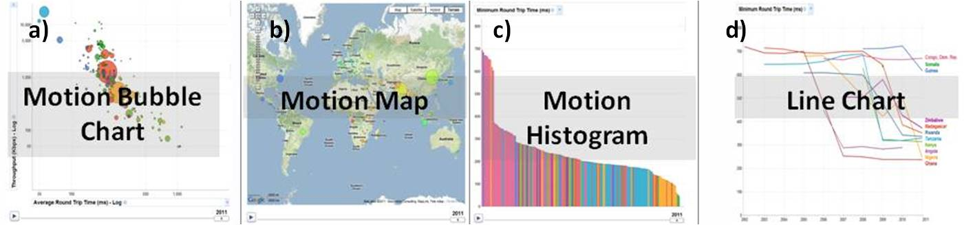
Figure 38 PingER Data Explorer. a) Motion Bubble chart. b) Motion Map. c) Motion Histogram. d) Line Chart

Figure 36a shows the motion bubble chart, any of the metrics mentioned above can be chosen for comparison by color of the bubble, size of the bubble, X-axis or Y-axis. Scale of X and Y axis can be selected as linear or log. The motion of the chart shows the yearly performance from 1998 to 2011. Figure 36b shows that you can visualize the above mentioned data sets on world map. This is good for looking at the continent performances or the countries performance in close view of the world or the neighboring countries. Figure 36c shows histogram of the performance of the countries. Choosing a country would highlight that country histogram and you can track or compare its performance with other countries over years. Figure 36d represents the metric performance in form of line chart. This is the only graph without motion. X-axis represents the years while y axis represents the metrics, with selected countries represented by the lines.

Appendix D: Growth in Number of Sites Monitored this Millennium
Towards the end of 2001 the number of sites monitored started dropping as sites blocked pings due to security concerns. The rate of blocking was such that, for example, out of 214 hosts that were pingable in July 2003, 33 (~15%) were no longer pingable in December 2003 even though they were still up and running (as measured by responding to TCP probes).

The increases in monitored sites towards the end of 2002 and early 2003 was due to help from the Abdus Salam Institute of Theoretical Physics (ICTP). The ICTP held a Round Table meeting on Developing Country Access to On-Line Scientific Publishing: Sustainable Alternatives in Trieste in November 2002 that included a Proposal for Real time monitoring in Africa. Following the meeting a formal declaration was made on Recommendations of the Round Table held in Trieste to help bridge the digital divide. The PingER project started collaborating closely with the ICTP to develop a monitoring project aimed at better understanding and quantifying the Digital Divide. On December 4th, 2002 the ICTP electronic Journal Distribution Service (eJDS) sent an email entitled Internet Monitoring of Universities and Research Centers in Developing Countries to their collaborators informing them of the launch of the monitoring project and requesting participation. By January 14th 2003, with the help of ICTP, we added about 23 hosts in about 17 countries including: Bangladesh, Brazil, China, Columbia, Ghana, Guatemala, India (Hyderabad and Kerala), Indonesia, Iran, Jordan, Korea, Mexico, Moldova, Nigeria, Pakistan, Slovakia and the Ukraine. The increase towards the end of 2003 was spurred by preparations for the second Open Round Table on Developing Countries Access to Scientific Knowledge: Quantifying the Digital Divide 23-24 November Trieste, Italy and the WSIS conference and associated activities in Geneva December 2003.

The increases in 2004 were due to adding new sites especially in Africa, S. America, Russia and several outlying islands.

In 2005, the Pakistan Ministry Of Science and Technology (MOST) and the US State Department funded SLAC and the National University of Sciences and Technology’s (NUST), School of Electrical Engineering and Computer Sciences (SEECS, formerly known as NUST Institute of Information Technology (NIIT)) to collaborate on a project to improve and extend PingER. As part of this project and the increased interest from Internet2 in the “Hard to Reach Network Places” Special Interest Group, many new sites in the South Asia and Africa were added to increase the coverage in these regions and also to replace sites that were blocking pings. For instance we were unable to find pingable sites in Angola prior to December 2005. Also as part of this project we started to integrate PingER with the NLANR/AMP project and as a result a number of the AMP nodes were added as PingER remote hosts in the developing regions. With help of Duncan Martin and the South Africa Tertiary Education Network (TENET) (http://www.tenet.ac.za), we successfully set up a monitoring node in South Africa, which became a great help in viewing the Digital Divide from within the Divide. With the help of SEECS, NUST (www.seecs.nust.edu.pk), a monitoring node was set up at NUST and in Nov. 2005, another node was added at NTC (National Telecommunication Corporation www.ntc.net.pk), which is the service provider for the PERN (Pakistan Educational and Research Network www.pern.edu.pk).

Again in 2006 in preparation for a conference on Sharing Knowledge across the Mediterranean at ICTP Trieste Nov 6-8, 2006, we added many new sites especially in Africa. Additionally, new monitoring nodes were setup in Pakistan (National Center for Physics (NCP)), Australia (University of New South Wales) and South Korea (Kyung Hee University).
In 2007, an effort was made to find new monitored nodes in countries not previously being observed. This was:
- To improve comparisons with human and economic development indices from the ITU, the UNDP, the World Bank, the CIA and also measures of International bandwidth capacity/country.
- To better enable validation of PingER derived throughputs versus throughput measures from Ookla Speedtest.net and ZDnet speedtest.
- To prepare for case studies on South Asia and Sub-Saharan Africa.
- To prepare for invited talks given at the American Physical Society (APS) meeting in Jacksonville Florida, the IHY in Addis Ababa, Ethiopia, and the Sharing Knowledge Foundation in Montpellier, France. In addition a talk was given at the Internet2 Spring Members meeting.
- To prepare for a visit to NUST in Pakistan and talks to be given there.
- Collaboration with James Whitlock of the Bethlehem Alliance resulted in two monitoring hosts in Palestine (Jerusalem and the Gaza Strip).
As a result, in 2007, the total number of hosts monitored from SLAC went up from 334 to 442, the main increases being in Africa which went from 58 to 95 hosts, South Asia from 20 to 37 hosts, Middle East 15 to 26 hosts, and South East Asia from 12 to 22 hosts. We added over a hundred new hosts from Ookla servers which cover over 50 countries.

In 2008 due to US Science budget cuts in particular in HEP, there were layoffs at SLAC and a redirection of goals that led to a much reduced support for PingER. This is discussed in the section “Outlook: cloudy” in http://www.symmetrymagazine.org/cms/?pid=1000639. Despite this, with some remaining funding from past projects, and with three graduate students from SEECS Pakistan and donating time, the project has successfully continued running.

In 2009 the support for PingER continued at a similar level to that in 2008. We were fortunate to have continued support from Pakistan, including 2-3 graduate students and a lecturer, at SLAC for a year. The increase in number of hosts in Africa was enabled by invited talks in Ethiopia and Zambia, a paper at a conference in Namibia, a series of four lectures to African computing and networking people at a meeting at the ICTP in Trieste, and a talk on African Internet performance at the European Geophysical Union in Vienna.

In 2010 support for PingER continued especially in Pakistan, where about 17 new nodes were added. NUST SEECS also sent 2 students for one year each for work related to the IEPM project, there was an increase in the number of hosts in Africa, Latin America, East Asia and South East Asia as well.

In 2011, NUST SEECS sent two more students for one year each for research related to the IEPM project. In 2011, there was a concentration on carefully locating the hosts to aid in geo-location and plotting on the PingER map. We also removed hosts not responsive for > 3 months and replaced those in developing countries with responsive hosts and where possible ensured that there were >=2 hosts in developing countries.

Since North America officially includes Mexico, the Encyclopedia Britannica recommendation is to use the terminology Anglo America (US + Canada). However, in this document North America is taken to mean the U.S. and Canada.
Internet World Statistics available at http://www.internetworldstats.com/stats1.htm
Ian Moore, comment in http://manypossibilities.net/african-undersea-cables/
A host is considered unreachable when none of the pings sent to it there is no response to any of the pings sent to it.
MonALISA, see http:// monalisa.caltech.edu
Pathload, see http://www.cc.gatech.edu/fac/Constantinos.Dovrolis/bw-est/pathload.html
What is perfSONAR available at http://www.perfsonar.net/
Iperf home page is available at http://dast.nlanr.net/Projects/Iperf/
"The GridFTP Protocol Protocol and Software". Available http://www.globus.org/datagrid/gridftp.html and also see http://en.wikipedia.org/wiki/GridFTP
Mean Opinion Score see http://en.wikipedia.org/wiki/Mean_opinion_score
The speed of light in fibre or copper is ~ 100km/ms. Knowing the distance (d) between the two hosts then d(km)=alpha*min_RTT(ms) 100(km/ms), where we use the min_RTT to minimize the effects of queuing and alpha accounts for the extra delays caused by network equipment (routers/switches etc.) and the indirectness of the path. The latter has the major impact on most long distance backbones. Typical values of alpha as seen by the TULIP project for reasonably direct paths are about 0.4.
ICFA/SCIC Monitoring Working Group’s Annual Reports, see http://www.slac.stanford.edu/xorg/icfa/scic-netmon/#annual
The Happy Planet Index 2.0, see http://www.happyplanetindex.org/
"PingER". Available http://www-iepm.slac.stanford.edu/pinger/; W. Matthews and R. L. Cottrell, "The PingER Project: Active Internet Performance Monitoring for the HEP Community", IEEE Communications Magazine Vol. 38 No. 5 pp 130-136, May 2002.
R. L. Cottrell, "Tutorial on Internet Monitoring & PingER at SLAC". See http://www.slac.stanford.edu/comp/net/wan-mon/tutorial.html
In special cases, there is an option to reduce the network impact to ~ 10bits/s per monitor-remote host pair.
PERFormance Service Oriented Network monitoring Architecture , see http://www.perfsonar.net/
"PingER Deployment". Available http://www.slac.stanford.edu/comp/net/wan-mon/deploy.html
"Requirements for WAN Hosts being Monitored", Les Cottrell and Tom Glanzman. Available at http://www.slac.stanford.edu/comp/net/wan-req.html
"United Nations Population Division World Population Prospects Population database". Available http://esa.un.org/unpp/definition.html
The difference in the number of active sites in Figure 3 and the ~780 reported in the Deployment section is the difference in the number of sites with active hosts in the last 30 days (lower number) and the number active in the last year.
R. L. Cottrell, "Tutorial on Internet Monitoring & PingER at SLAC". Available http://www.slac.stanford.edu/comp/net/wan-mon/tutorial.html
M. Mathis, J. Semke, J. Mahdavi, T. Ott, "The Macroscopic Behavior of the TCP Congestion Avoidance Algorithm",Computer Communication Review, volume 27, number 3, pp. 67-82, July 1997
Geosynchronous satellite, see http://en.wikipedia.org/wiki/Geosynchronous_satellite
World Bank Supports Submarine Communications Cable and Helps Unlock High-Speed Opportunities, see http://web.worldbank.org/WBSITE/EXTERNAL/TOPICS/EXTINFORMATIONANDCOMMUNICATIONANDTECHNOLOGIES/EXTEDEVELOPMENT/0,,contentMDK:23017590~menuPK:559467~pagePK:64020865~piPK:149114~theSitePK:559460,00.html
Republic of Congo Ready to Surf the High Speed Internet, see http://www.afriqueavenir.org/en/2011/07/28/republic-of-the-congo-ready-to-surf-with-high-speed-internet/
African Undersea cables, see http://manypossibilities.net/african-undersea-cables/
A notable effect on derived throughput is that for measurements made from say a N. American site, such as SLAC, to other N. American sites, 1/RTT is large and so throughputs are artificially enhanced compared to measurements to more distant regions with longer RTTs.
Interquartile Range, see http://en.wikipedia.org/wiki/Interquartile_range
Calculating the MOS, see http://www.slac.stanford.edu/comp/net/wan-mon/tutorial.html#mos
The PingER team is successfully holding weekly meetings using VoIP calls using Skype between SLAC in California and NUST in Islamabad, Pakistan. The quality is pretty good. The main problem is loss of connectivity due to power outages in Pakistan.
Measuring the Information Society, from the ITU , see http://www.itu.int/ITU-D/ict/publications/idi/2011/
Human Development Index, see http://hdr.undp.org/reports/global/2002/en/
Pearson product-moment correlation coefficient, see http://en.wikipedia.org/wiki/Pearson_product-moment_correlation_coefficient
Happy Planet Index, see http://en.wikipedia.org/wiki/Happy_Planet_Index
Magnitude 9.0 - NEAR THE EAST COAST OF HONSHU, JAPAN, see http://earthquake.usgs.gov/earthquakes/recenteqsww/Quakes/usc0001xgp.php
The Arab Spring, see http://en.wikipedia.org/wiki/Arab_Spring
Pakistani Case Study 2010, see https://confluence.slac.stanford.edu/display/IEPM/Pakistani+Case+Study+2010-2011
PERN Six Monthly Report (June 2011-Novem,ber 2011), see https//
Measuring Voice Quality, see http://www.voiptroubleshooter.com/basics/mosr.html.
See the case study at https://confluence.slac.stanford.edu/display/IEPM/Pakistani+Case+Study+2010-2011
“End-to-end Performance Initiatives Performances Environment System”, Internet2, see http://e2epi.internet2.edu/e2epipes//index.html
“Version 2.0 of Advisor Realesed”, NCSA, see http://access.ncsa.illinois.edu/Releases/05Releases/03.08.05_Version_2..html
“MonALISA: LISA”, Caltech, see http://monalisa.cern.ch/monalisa__Interactive_Clients__LISA.html
“OGF Network Measurement Working Group”, Internet2, see http://nmwg.internet2.edu/
“Global Lambda Integrated Facility”, see http://www.glif.is/
“DANTE-Internet2-CANARIE-ESnet collaboration, see http://www.geant2.net/server/show/conWebDoc.1308
http://www.internet2.edu/performance/ndt/index.html
“Performance focused Service Oriented Network monitoring Architecture”, see https://wiki.man.poznan.pl/perfsonar-mdm/index.php/Main_Page
The main webpage is http://lhcone.net
“An Ultrascale Information System for Data Intensive Research”, see http://www.ultralight.org/web-site/ultralight/html/index.html
“Terapaths”, https://www.racf.bnl.gov/terapaths/
“Lambda Station”, see http://www.lambdastation.org/
“ESnet On-demand Secure Circuits and Advance Reservation System”, ESnet, see http://www.es.net/oscars/index.html
“End Site Control Plane Surface”, see https://plone3.fnal.gov/P0/ESCPS
“Development of Dynamic Network System”, Internet2, see http://www.internet2.edu/ion/dynes.html
Mike Jensen, "Connectivity Mapping in Africa", presentation at the ICTP Round Table on Developing Country Access to On-Line Scientific Publishing: Sustainable Alternatives at ITCP, Trieste, October 2002. Available http://www.ictp.trieste.it/~ejds/seminars2002/Mike_Jensen/jensen-full.ppt
"ICFA/SCIC meeting at CERN in March 2002". Available http://www.slac.stanford.edu/grp/scs/trip/cottrell-icfa-mar02.html
Quantifying the Worldwide Digital Divide: the Emergence of Africa, see http://www.slac.stanford.edu/grp/scs/net/talk11/aps-apr11.pptx
PingER End to End Internet Measurements: What we Learn, see http://www.slac.stanford.edu/grp/scs/net/talk11/icann-mar11.pptx
Quantifying the Worldwide Digital Divide: the Emergence of Africa, see http://www.slac.stanford.edu/grp/scs/net/talk11/africa-sep11.pptx
Table of Contents of Lectures, see http://www.slac.stanford.edu/grp/scs/net/talk11/kinshasa-toc.docx
An Introduction to PingER motion charts, see http://www.youtube.com/watch?v=vK7UOpTskyg
PingER Map, see http://www-wanmon.slac.stanford.edu/wan-mon/viper/pinger-coverage-gmap.html
PingER home page, see http://www-iepm.slac.stanford.edu/pinger/
TULIP Trilateration Utility for Locating IP hosts, see http://www.slac.stanford.edu/comp/net/wan-mon/tulip/
Traceroute archive, see https://confluence.slac.stanford.edu/display/IEPM/Traceroute+Archive
Derivation of the Directness of Connection, see https://confluence.slac.stanford.edu/display/IEPM/Derivation+of+Directness+of+Connection
PingER Data Explorer, see http://www-iepm.slac.stanford.edu/pinger/explorer.html
Google Public Data, see http://www.google.com/publicdata/directory
Developing Country Access to On-Line Scientific Publishing: Sustainable Alternatives, Round Table meeting held at ICTP Trieste, Oct 2002. Available http://www.ictp.trieste.it/~ejds/seminars2002/program.html
Enrique Canessa, "Real time network monitoring in Africa - A proposal - (Quantifying the Digital; Divide)". Available http://www.ictp.trieste.it/~ejds/seminars2002/Enrique_Canessa/index.html
RECOMMDENDATIONS OF the Round Table held in Trieste to help bridge the digital divide. Available http://www.ictp.trieste.it/ejournals/meeting2002/Recommen_Trieste.pdf
Hilda Cerdeira and the eJDS Team, ICTP/TWAS Donation Programme, "Internet Monitoring of Universities and Research Centers in Developing Countries". Available http://www.slac.stanford.edu/xorg/icfa/icfa-net-paper-dec02/ejds-email.txt
“South Asia case Study”, Les Cottrell, available at: https://confluence.slac.stanford.edu/display/IEPM/South+Asia+Case+Study
“Sub-Sahara case Study”, Les Cottrell, available at: https://confluence.slac.stanford.edu/display/IEPM/Sub-Sahara+Case+Study
“Quantitative Measurement of the Digital Divide”, Les Cottrell, Shahryar Khan, presented at the April APS meeting, Jacksonville Florida April 15, 2007
“Internet View of the Digital Divide, Especially for Sub-Saharan Africa,” presented by Les Cottrell at the IHY Africa Workshop 11-16 November 2007, Addis Ababa, Ethiopia
“Internet Connectivity in Africa” , presented by Les Cottrell at the Internet and Grids in Africa: An Asset for African Scientists for the Benefit of African Society, 10-12 December 2007, Montpellier France.

